1.PROJECT PROFILE

|  |  |
| --- | --- |
| 1.1 | Project Definition |
| 1.2 | Project Scope |
| 1.3 | Project Objective |

**Project Profile**

|  |  |
| --- | --- |
| **Project Title** | Tourism Management System |
| **Developed By** | Chauhan Bina [3052001099]  Jivani Ankita [3052001100]  Poshiya Jensi [3052000386] |
| **Semester** | BCA SEM – 6 |
| **Guidance By** | HTML,CSS,  JAVA-SCRIPT, MYSQL |
| **Platform** | DJANGO ,HTML,CSS  JAVA SCRIPT |
| **Project Type** | Web Application |
| **Submitted By** | Dr. Subhash College of Computer Science, Junagadh |
| **Submitted to University** | BKNMU University-Junagadh |

* 1. **Project Definition**
* Tourism Management System is a web-based technology that manages tour package and customer to easily book and find information about place.
* Tourism Management System is a web-based system which help tourist to see available package in company and book that package online to save time and money.
* Administration can store the data of package . The System also keeps the user book info**.**
* This project uses Django and MySQL, SQLite databases, and it has a module that is admin. All possible features such as validation, security, etc., are considered.
* The proposed system influences or interacts with tourist that can find any online service to book its package.
* This project also includes system testing and validation, which ensures that your System is error-free and working as expected.

**1.2 Project Scope**

* Tourism Management System is an integrated software developed for tour operating companies.
* The main aim of this project is to help the tourism companies to manage their customers, vehicles, and agent.
* It makes all operation of the tour company easy and accurate.
* The standalone platform makes tourism management easy by handing agencies requests and providing servers for the customers located at different parts of the various cities.
* Different modules have been incorporated in this project to handle different parts and sector of the tour management field.

**1.3 Project Objective**

* The Tourism Management System is a web based application and maintains a centralized repository of all related information.
* The Objective of this project is to develop a system that automates the process and activities a travel agency and customer details.
* The purpose is to design a system using which one can perform all operations related to travelling and sight-seeing.
* The main objective of this sector is to develop and promote tourism, maintain competitiveness of India as tourist destination and improve and expand existing tourism products to ensure employment generation and economic growth.

1. System Analysis and Specification

|  |  |
| --- | --- |
| 2.1 | Existing System |
| 2.2 | Limitations of Existing System |
| 2.3 | Feasibility Study |
| 2.4 | Need of New System |
| 2.5 | Front End & Back End Tools |

**2.1 Existing System**

* The present systems are inadequate in providing information and advices to the agencies and customers about tour plans.
* Often agencies are compelled to rely on local information sources and count on their own experience regarding time and cost.
* Through phone call they have to get information.
* There are some problems which are existing in my System those are given below concisely.
  + There will be many users visiting the portal and hence we require a strong and reliable front-end which can withhold the users on our site.
  + We need a strong Database whereas data will be store of everyone.

**2.2 Limitation of Existing System**

* User can select class and view all class.
* User can view all type of package information and it details.
* User can view Information about Website.
* User can give Feedback.
* with successful login user can booking any kind of package.
* Admin can view registration.
* Admin can view user booking details.
* Admin can all type information in details.
* Admin can change the package like update, delete, insert…

**3.Feasibility Study**

* Feasibility study is the likelihood that whether the system will be useful to the organization or not.
* After studying the requirements, whether the proposed project is feasible or not is determined by checking the various feasibilities.
* The main aim of the feasibility study is to determine whether developing system is financially and technically feasible.
* The feasibility study involves analysis of the problem and collection of data which would be input to the system, the processing required to be carried out on these data.
* The three aspects in the feasibility study portion are:

1. Technical Feasibility
2. Economical Feasibility
3. Operational Feasibility
4. **Technical Feasibility:**

* Since the main aim of technical feasibility study is to determine whether unit posses the hardware as well as related software for the project.
* Proposed system does not require much technical detail.
* The current manual system is not so much sufficient for processing of all kinds of tasks.
* It needs low configuration computer system or high configuration computer system and the required operation system.
* It just required windows operating system.
* The organization is ready to purchase the entire required device, required by the proposed system.
* This technical specification is easily available in the market.
* Therefore the proposed system is technical feasible.

1. **Economical Feasibility:**

* The organization is ready to invest in the proposed system for latest technology and better result.
* As the personnel and the manager know the computer operating, the unit need not have to appoint any computer operator.
* If any of the staff in the firm knows how to operate the computer, than the firm needs number to recruit a new person.
* The unit has to spend not much amount for the computer hardware and software.
* The organization is capable for paying the money for proposed system.
* Therefore the project possesses the economical feasibility.

1. **Operational Feasibility:**

* The possibility of the operational feasibility is as under.
* The proposed system will fulfill the firm’s requirements.
* The proposed system covers all the aspect of the working system.
* The expected users of the proposed system re honestly ready for the new system.
* The changes made in this system are quite beneficial or not.

**2.4 Need of New System**

* The purpose is to build a system that performs all operations related to traveling, booking, sightseeing, etc.
* This system connects customers and agents directly, provides a feedback mechanism for tourists, maintains and controls the database of tourists' information, and gives a variety of travel services.
* Tourism is a social, cultural and economic phenomenon which entails the movement of people to countries or places outside their usual environment for personal or business/professional purposes.

**2.5 Front End & Back End Tools**

* **Front End Tools :**

1. CSS,
2. HTML5,
3. JAVA SCRIPT
4. **CSS :**

* **C**ascading **S**tyle **S**heets, fondly referred to as CSS, is a simple design language intended to simplify the process of making web pages presentable.
* CSS handles the look and feel part of a web page.
* Using CSS, you can control the colour of the text, the style of fonts, the spacing between paragraphs, how columns are sized and laid out, what background images or colours are used, layout designs, and variations in display for different devices and screen sizes as well as a variety of other effects.
* CSS is easy to learn and understand but it provides powerful control over the presentation of an HTML document.
* Most commonly, CSS is combined with the markup languages HTML or XHTML.

1. **HTML5 :**

* HTML is short for "Hypertext mark-up Language". That may sound scary, but it simply means it is a language for describing web-pages using ordinary text.
* HTML is not a complex programming language. Hypertext is the method by which you move around on the web — by clicking on special text called hyperlinks which bring you to the next page.
* The fact that it is hyper just means it is not linear.
* HTML is a Language, as it has code-words and syntax like any other language.
* The DOCTYPE declaration for HTML5 is very simple: <!DOCTYPE html>
* The character encoding (charset) declaration is also very simple:< Meta charset="UTF8">
* The most interesting new HTML5 elements are: New semantic elements like <header>, <footer>, <article>, and <section>.

1. **JAVA SCRIPT :**

* A scripting language is a lightweight programming language.
* JavaScript is programming code that can be inserted into HTML pages.
* JavaScript code can be executed by all modern web browsers.
* JavaScript is the scripting language of the Web.
* All modern HTML pages are using JavaScript.

**JavaScript** to program the behaviour of web pages.

* JavaScript is a scripting language that enables you to create dynamically updating content, control multimedia, animate images, and pretty much everything else.
* **Back End Tools :**
  + - 1. Python-Django,
      2. MySQL Database
      3. SqLite Database

1. **Python-Django :**

* **What is Django?**
* Django is a Python-based web framework which allows you to quickly create web application without all of the installation or dependency problems that you normally will find with other frameworks.
* When you’re building a website, you always need a similar set of components: a way to handle user authentication (signing up, signing in, signing out), a management panel for your website, forms, a way to upload files, etc. Django gives you ready-made components to use**.**
* **Why Django?**
* It’s very easy to switch database in Django framework

.

* It has built-in admin interface which makes easy to work with it.
* Django is fully functional framework that requires nothing else.
* It has thousands of additional packages available.
* **Features of Django**
* **Versatility of Django :**
* Django can build almost any type of website. It can also work with any client-side framework and can deliver content in any format such as HTML, JSON, XML etc.
* Some sites which can be built using Django are wikis, social networks, new sites etc.
* **Security :**
* Since Django framework is made for making web development easy, it has been engineered in such a way that it automatically do the right things to protect the website.
* For example, In the Django framework instead of putting a password in cookies, the hashed password is stored in it so that it can’t be fetched easily by hackers.
* **Scalability :**
* Django web nodes have no stored state, they scale horizontally – just fire up more of them when you need them.
* Being able to do this is the essence of good scalability.
* Instagram and Disqus are two Django based products that have millions of active users, this is taken as an example of the scalability of Django.
* **Portability :**
* All the codes of the Django framework are written in Python, which runs on many platforms.
* Which leads to run Django too in many platforms such as Linux, Windows and Mac OS.
* **Open Source :**
* Django is an open source web application framework. It is publicly available without cost.
* It can be downloaded with source code from the public repository.
* Open source reduces the total cost of the application development.
* **Vast and Supported Community :**
* Django is an one of the most popular web framework.
* It has widely supportive community and channels to share and connect**.**

1. **MySQL Database :**

* MySQL is currently the most popular database management system software used for managing the relational database.

* It is open-source database software, which is supported by Oracle Company.
* It is fast, scalable, and easy to use database management system in comparison with Microsoft SQL Server and Oracle Database.
* It is commonly used in conjunction with [PHP](https://www.javatpoint.com/php-tutorial) And Other scripts for creating powerful and dynamic server-side or web-based enterprise applications.
* It is developed, marketed, and supported by MySQL AB, a Swedish company, and written in [C programming language](https://www.javatpoint.com/c-programming-language-tutorial) and [C++ programming language](https://www.javatpoint.com/cpp-tutorial).
* The official pronunciation of MySQL is not the My Sequel; it is My Ess Que Ell. However, you can pronounce it in your way. Many small and big comanies use MySQL.
* MySQL supports many Operating Systems like [Windows](https://www.javatpoint.com/windows), [Linux](https://www.javatpoint.com/linux-tutorial), MacOS, etc. with C, C++, and [Java languages](https://www.javatpoint.com/java-tutorial).

1. **SqLite Database :**

* SQLite is an in-process library that implements a self-contained, serverless, zero-configuration, transactional SQL database engine.
* It is a popular choice as an embedded database for local/client storage in application software such as web browsers.

* It is also used in many other applications that need a lightweight, embedded database.
* SQLite is ACID-compliant and implements most of the SQL standards, using a dynamically and weakly typed SQL syntax that does not guarantee domain integrity.
* To use SQLite in a C/C++ program, you can use the sqlite3 API, which provides a lightweight, simple, self-contained, high-reliability, full-featured, and SQL database engine.
* The API is implemented as a library of C functions that can be called from your program.
* One of the main benefits of using SQLite is that it is very easy to get started with.
* To create a new database in SQLite, you simply need to create a new file on your filesystem and connect to it using the sqlite3 API.

3.System Requirement Specification

|  |  |
| --- | --- |
| 3.1 | Proposed System and Advantages |
| 3.2 | Development Strategy Model |

**3.1 Proposed System and Advantages**

* The proposed system is designed to be more efficient than the manual system.
* It invokes all base tasks that are now carried out manually, such as the forms transactions.
* And reports which is added advantage. The proposed System is completely computer-based application.
* Thousands of records can searched and displayed without taking any significant time.
* **Advantages of the Proposed System**:
* Gives accurate information
* Simplifies the manual work
* It minimizes the documentation related work
* Provides up to date information
* Friendly Environment by providing warning messages.
* Travelers details can be provided
* Booking confirmation notification

**3.2 Development Strategy Model**

* **Implementation Methodology**
* All projects follow a life cycle model (SDLC). The most widely used SDLC model in our project is:

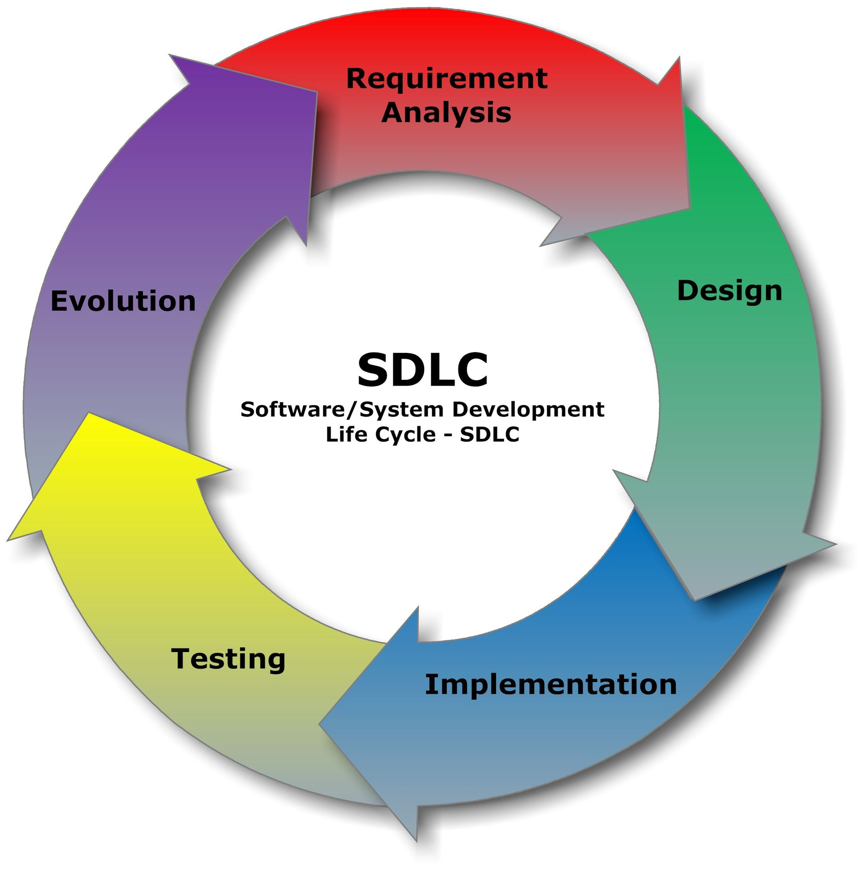

## Requirement Analysis:

* **Functional Requirements:**
* Organization has following basic requirements to be performed by the website. So, user can be able to get following functionality from website.
* Information about online Tour ticket booking system.
* Information about different types of Tour ticket booking.
* Admin can view and approve or cancel booking detail.
* User Can view ticket and cancel his booking.
* User able to update registration details.
* Secure User Login account.
* **Designing**:
* Once the analysis is done now it’s time for designing. It is the process by which a person creates a specification of a software artifact, intended to accomplish goals, using a set of primitive components and subject to constraints

.

* Software design usually involves problem solving and planning a software solution.

* This includes both low-level component and algorithm design and high-level, architecture design.
* After completing work related to information collecting we started to work on the designing the website.
* We designed a database, a master page for Admin as well as for user also then we started designing each & every web page of the website.
* **Implementation:**
* This phase is initiated after the system has been tested and accepted by the user.
* In this phase, the system is installed to support the intended business functions.
* System performance is compared to performance objectives established during the planning phase.
* Implementation includes user notification, user training, installation of hardware, installation of software onto production computers, and integration of the system into daily work processes.
* This phase continues until the system is operating in production in accordance with the defined user requirements.
* **Coding**:
* The design must be translated in machine readable form. It performs this task. If design is performed in a detailed manner, code generation can be accomplished mechanically.
* When the designing was completed we implemented the logic of the form into the .py and .css files by debugging each.

# **Testing:**

* Once code has been generated, software testing begins. It is done before the release to the final audience. Software testing is meant to see how the software works under different conditions.

* Testing is done to understand if it will work correctly, partially fail to work properly, or totally fail to work properly.
* Each test may be used to see how one, or many, parts of the software work at a point in its development.
* Prescriptive process models define a distinct set of activities, actions, tasks, milestones, and work products, that are required to engineer high-quality software.
* They do provide a useful roadmap for software engineering work. We discuss here the strategy of the system development in detail as the Register and search Application is developed using this strategy.
* The SDLC method is classically thought of as the set of activities that Analyst, designer and user carry out to develop and implement an information system. This method consists of six steps.

4. System Design

|  |  |
| --- | --- |
| 4.1 | Data Flow Diagram |
| 4.2 | E-R Diagram |
| 4.3 | Class Diagram |
| 4.4 | Use Case Diagram |
| 4.5 | Sequence Diagram |
| 4.6 | Activity Diagram |
| 4.7 | Data Dictionary (Database) |

**4.1 Data Flow Diagram**

## Data Flow Diagram (DFD)

* The Data Flow Diagram (DFD) is a graphical representation of the flow of data through an information system.
* It enables you to represent the processes in your information system from the viewpoint of data.
* At a technical level, we did as all other programmers begin with the series of modelling task that lead to complete specification of requirements and comprehensive design representation for the software to be built.
* We used data flow diagrams to represent the information flow and Transforms that are applied as data move from input to output.

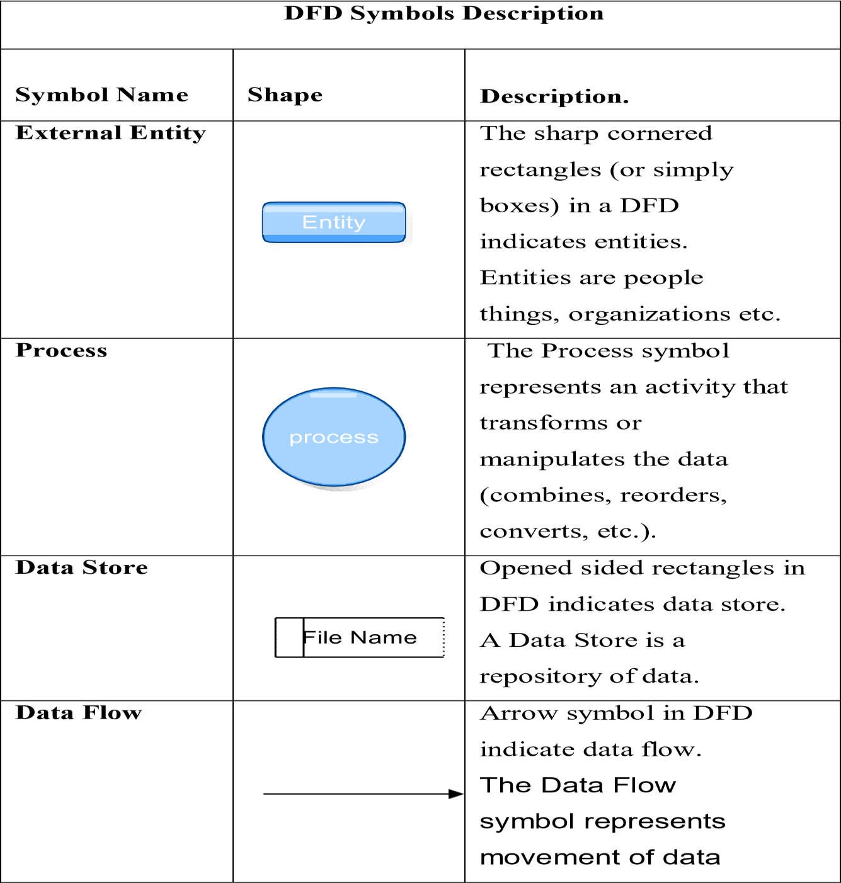

* There Three Type of Data flow diagram:
  + - 1. Level 0 or Context Diagram
      2. Level 1 Diagram
      3. Level 2 Diagram

**1.Level 0 or Context Diagram**

* It is common practice to draw the context-level data flow diagram first, which shows the interaction between the system and external agents which act as data sources and data sinks. This helps to create an accurate drawing in the context diagram.
* The system's interactions with the outside world are modeled purely in terms of data flows across the system boundary. The context diagram shows the entire system as a single process, and gives no clues as to its internal organization.

1. **Level 1 Diagram**

* This context-level DFD is next "exploded", to produce a Level 1 DFD that shows some of the detail of the system being modelled.
* The Level 1 DFD shows how the system is divided into subsystems (processes), each of which deals with one or more of the data flows to or from an external agent, and which together provide all of the functionality of the system as a whole.

**3.Level 2 Diagram**

* A level 2 data flow diagram (DFD) offers a more detailed look at the processes that make up an information system than a level 1 DFD does. It can be used to plan or record the specific makeup of a system.
* To edit this DFD level 2 template, just sign up for a free Lucid chart account. You can then input the particulars of your own system.

# **1. Tourism (Level-0)**

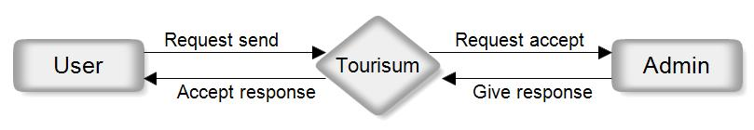

**Admin** **Side** **(Level-1)**

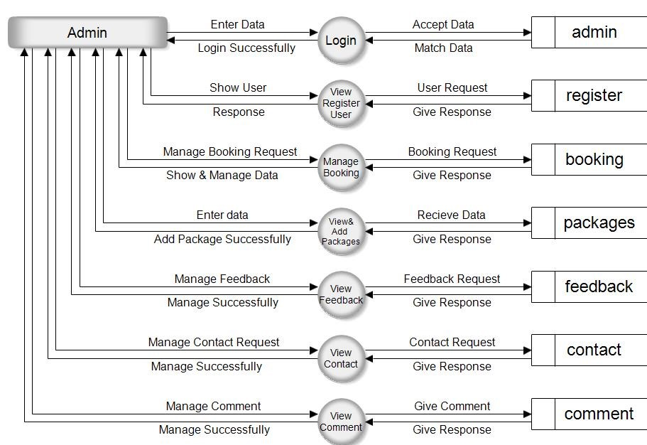

**User** **Side** **(Level-1)**

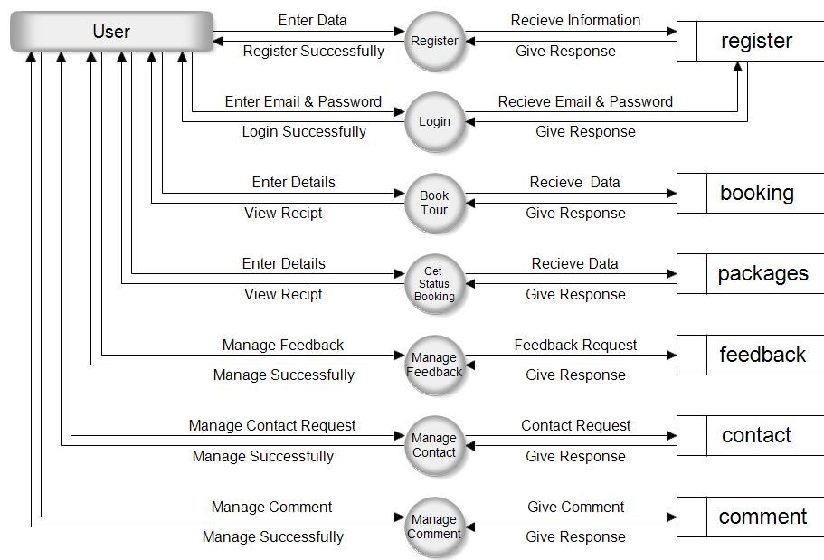

**4.2 ER Diagram**

* An entity-relationship diagram (ERD) is a data modeling technique that graphically illustrates an information system's entities and the relationships between those entities.
* An ERD is a conceptual and representational model of data used to represent the entity framework infrastructure.
* Database troubleshooting: ER diagrams are used to analyze existing databases to find and resolve problems in logic or deployment.
* Drawing the diagram should reveal where it's going wrong. Business information systems: The diagrams are used to design or analyze relational databases used in business processes.
* An entity-relationship model (ERM) is a theoretical and conceptual way of showing data relationships in software development.
* ERM is a database modeling technique that generates an abstract diagram or visual representation of a system's data that can be helpful in designing a relational database.

## ➔Entity Relationship Diagram Notations

Peter Chen developed ERDs in 1976. Since then Charles Bachman and James Martin have added some slight refinements to the basic ERD principles.

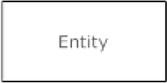**Entity**

An entity is an object or concept about

which you want to store information

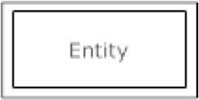**Weak Entity**

Attributes are the properties or characteristics of entity.

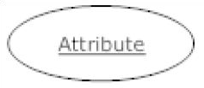**Key** **attribute**

A key attribute is the unique, distinguishing characteristic of the entity. For example, an employee's social security number might be the employee's key attribute.

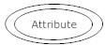 **Multivalued** **attribute**

A multivalued attribute can have more than one value. sFor example, an employee entity can have multiple values.

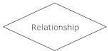**Relationships**

Relationships illustrate how two entities share information in the database structure.

# **ER Diagram**

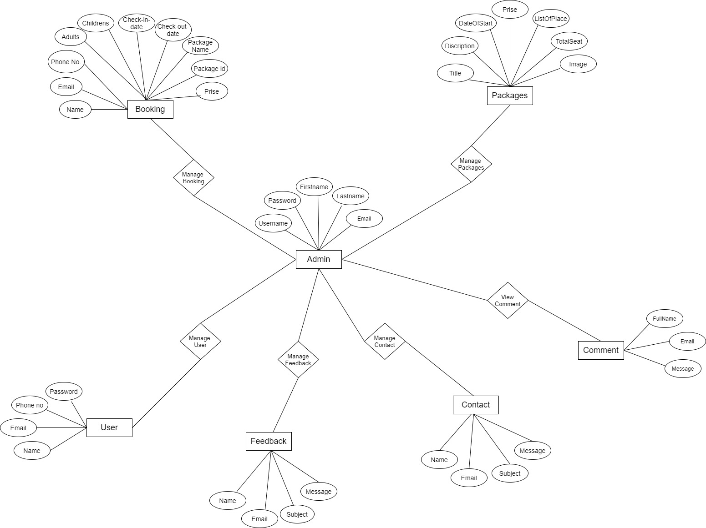

**4.3 Class Diagram**

* A class diagram is an illustration of the relationships and source code dependencies among classes in the Unified Modeling Language (UML).
* In this context, a class defines the methods and variables in an object, which is a specific entity in a program or the unit of code representing that entity.
* Class diagrams are useful in all forms of object-oriented programming (OOP).
* The concept is several years old but has been refined as OOP modeling paradigms have evolved.
* A class diagram resembles a flowchart in which classes are portrayed as boxes, each box having three rectangles inside.
* **Purpose of Class Diagrams:**
* Shows static structure of classifiers in a system.
* Diagram provides a basic notation for other structure diagrams prescribed by UML.
* Helpful for developers and other team members too.
* Business Analysts can use class diagrams to model systems from a business perspective.
* 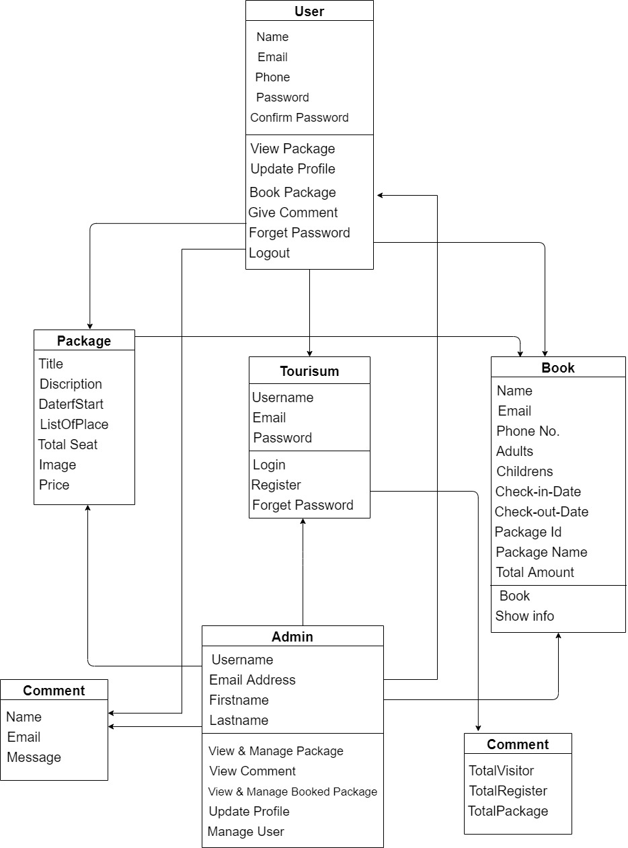**Class Diagram**

**4.4 Use Case Diagram**

* A use case diagram is a graphic depiction of the interactions among the elements of a system. A use case is a methodology used in system analysis to identify, clarify, and organize system requirements. The actors, usually individuals involved with the system defined according to their roles.
* UML Use Case Diagrams. Use case diagrams are usually referred to as behavior diagrams used to describe a set of actions (use cases) that some system or systems (subject) should or can perform in collaboration with one or more external users of the system (actors).
* The main purpose of a use case diagram is to show who interacts with your system, and the main goals they achieve with it. Create Actors to represent classes of people, organizations, other systems, software or devices that interact with your system or subsystem.
* Use Cases. A use case is a written description of how users will perform tasks on your website. It outlines, from a user's point of view, a system's behavior as it responds to a request. Each use case is represented as a sequence of simple steps, beginning with a user's goal and ending when that goal is fulfilled.

|  |  |  |
| --- | --- | --- |
| **Use Case Symbols Description** | | |
| **Symbol Name** | **Shape** | **Description** |
| **Actor** |  | Similar to the concept of user, but a user can play different roles. |
| **Use Case** |  | Each Actor must  be linked to a use case, while  some  use cases may not be linked  to  actors. |
| **Communication Link** |  | The participation of an actor in a use case is  shown by  connecting a actor to a use case by a solid link. |
| **Boundary Of System** |  | The system boundary is  potentially the entire system as defined in the requirements  document. |

# **Admin Side**

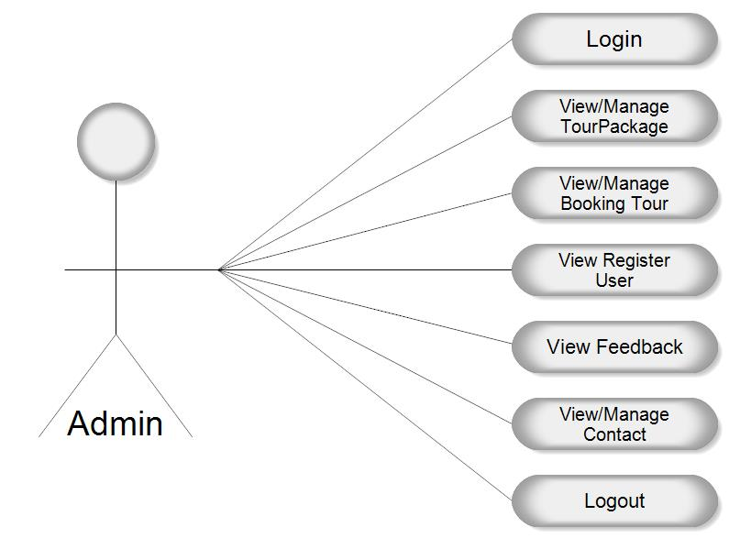

# **User Side**

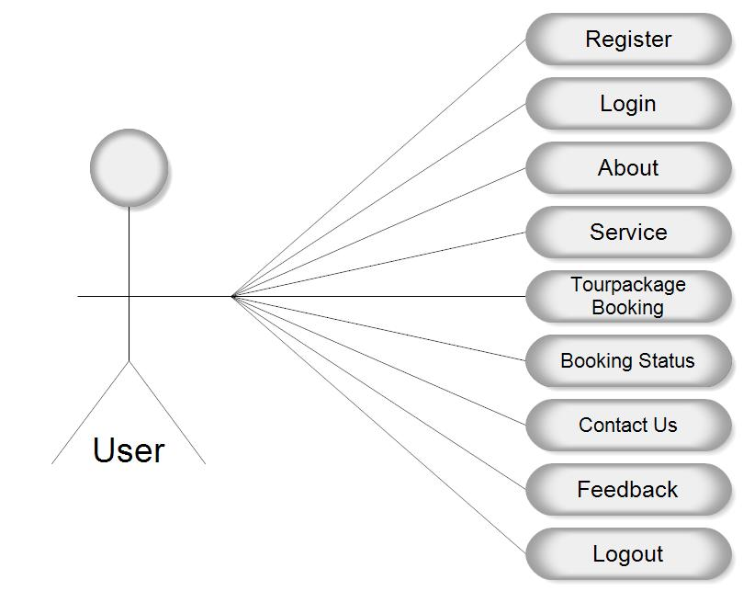

**4.5 Sequence Diagram**

* The sequence diagram represents the flow of messages in the system and is also termed as an event diagram.
* It helps in envisioning several dynamic scenarios. It portrays the communication between any two lifelines as a time-ordered sequence of events, such that these lifelines took part at the run time.
* In UML, the lifeline is represented by a vertical bar, whereas the message flow is represented by a vertical dotted line that extends across the bottom of the page.
* It incorporates the iterations as well as branching.
* **Purpose of a Sequence Diagram**
* To model high-level interaction among active objects within a system.
* To model interaction among objects inside a collaboration realizing a use case.
* It either models generic interactions or some certain instances of interaction.
* **Sequence Diagram**

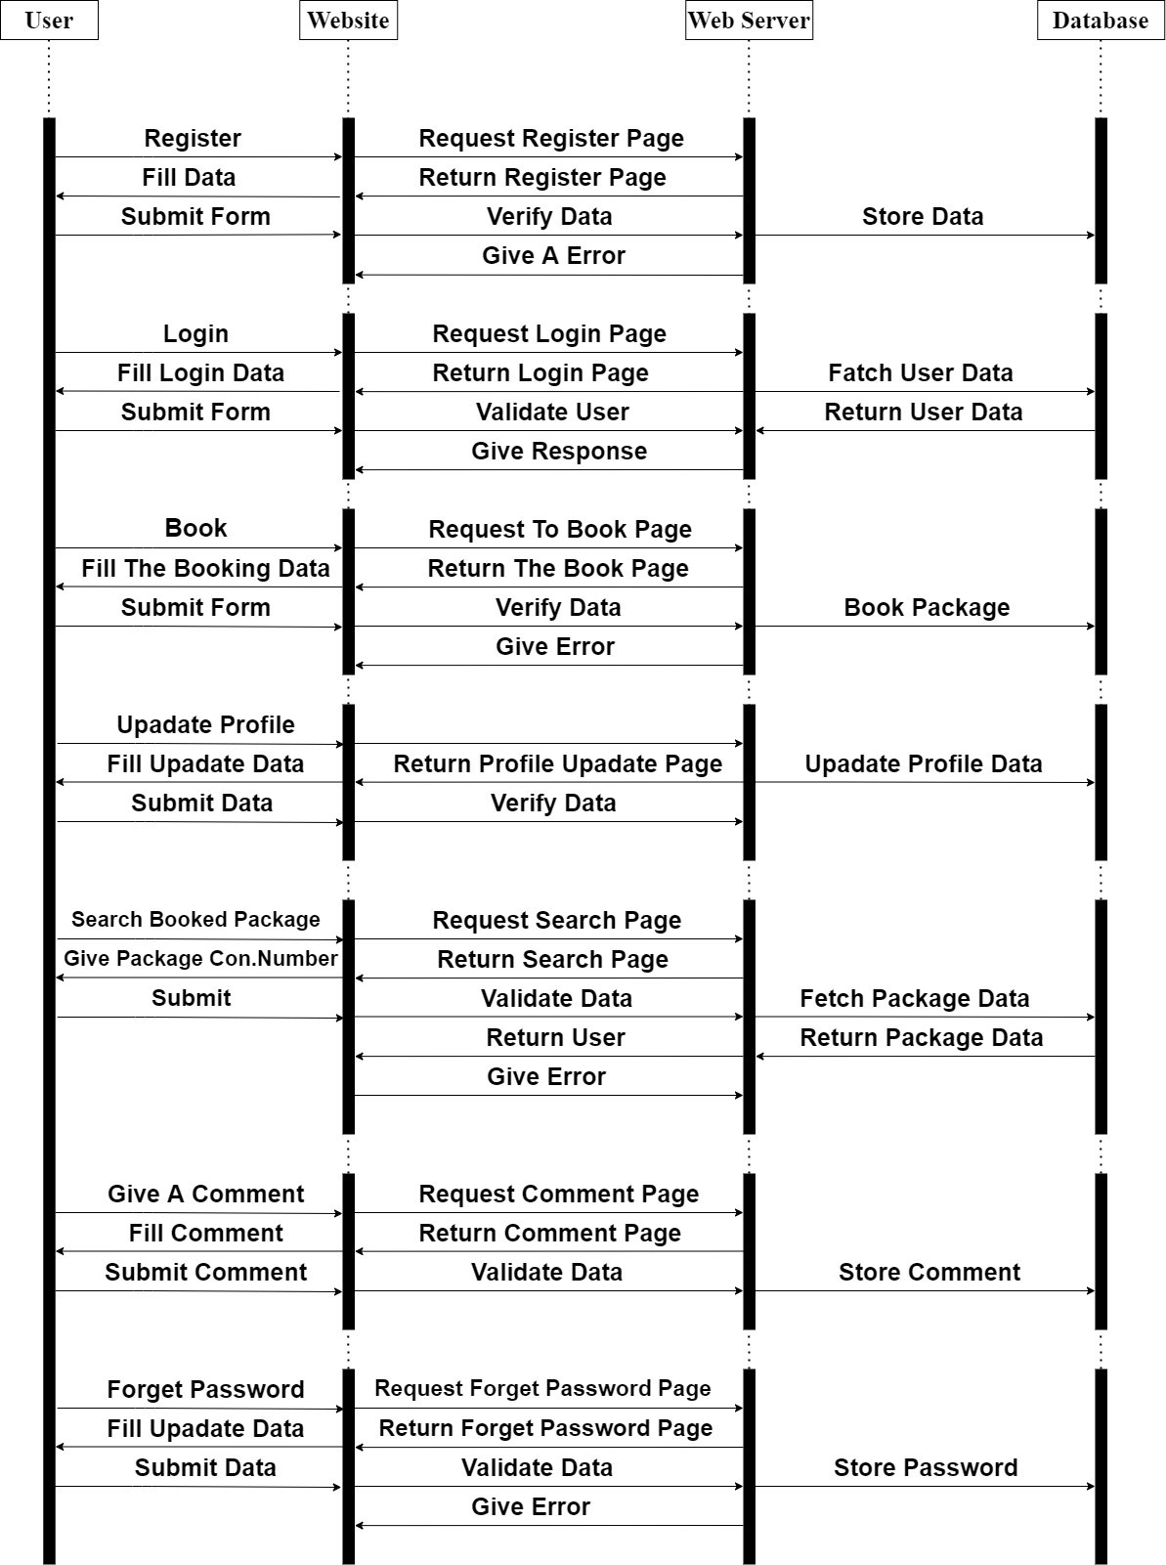

**4.6 Activity Diagram**

* Activity diagrams are mainly used as a flowchart that consists of activities performed by the system.
* Activity diagrams are not exactly flowcharts as they have some additional capabilities. These additional capabilities include branching, parallel flow, swimlane, etc.
* Before drawing an activity diagram, we must have a clear understanding about the elements used in activity diagram.
* The main element of an activity diagram is the activity itself. An activity is a function performed by the system. After identifying the activities, we need to understand how they are associated with constraints and conditions.
* Before drawing an activity diagram, we should identify the following elements:
* Activities
* Association
* Conditions
* Constraints
* The purpose of an activity diagram can be described as –
* Draw the activity flow of a system.
* Describe the sequence from one activity to another.
* Describe the parallel, branched and concurrent flow of the system.
* **Activity Diagram**

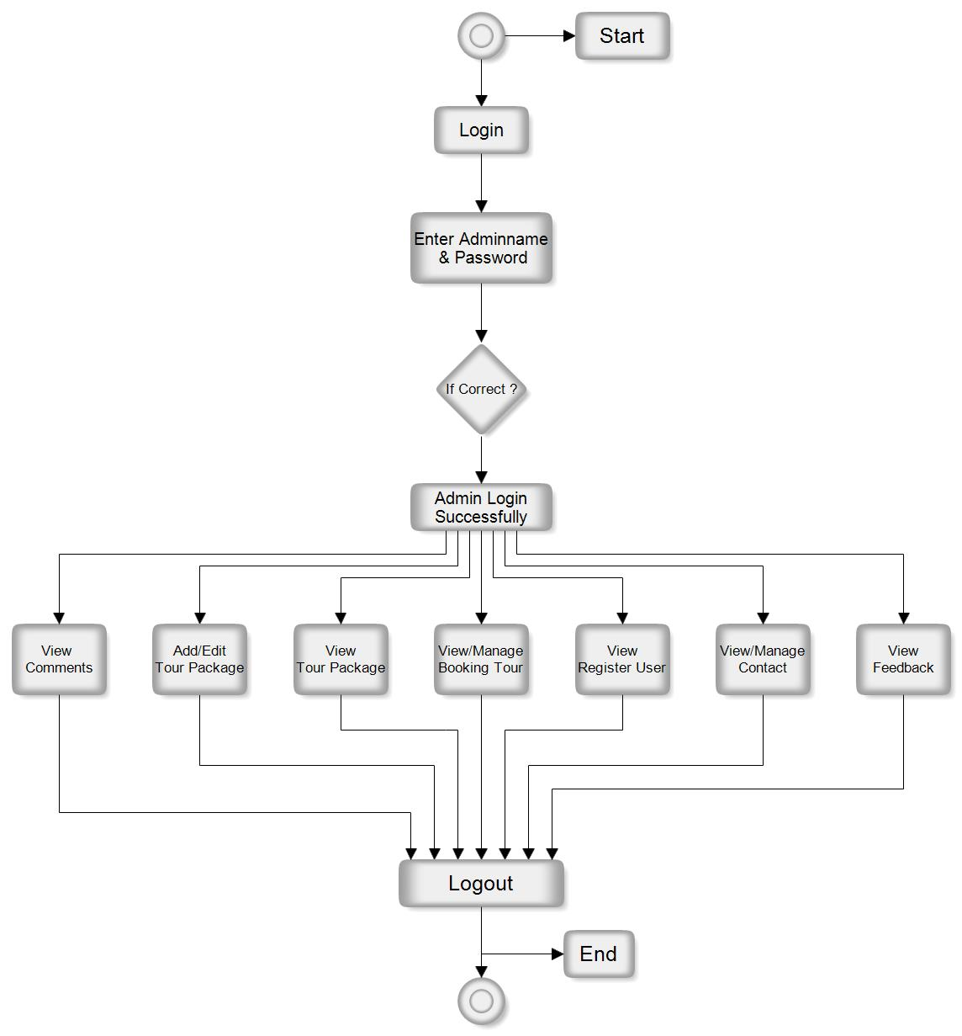**Admin Side**

# **User Side**

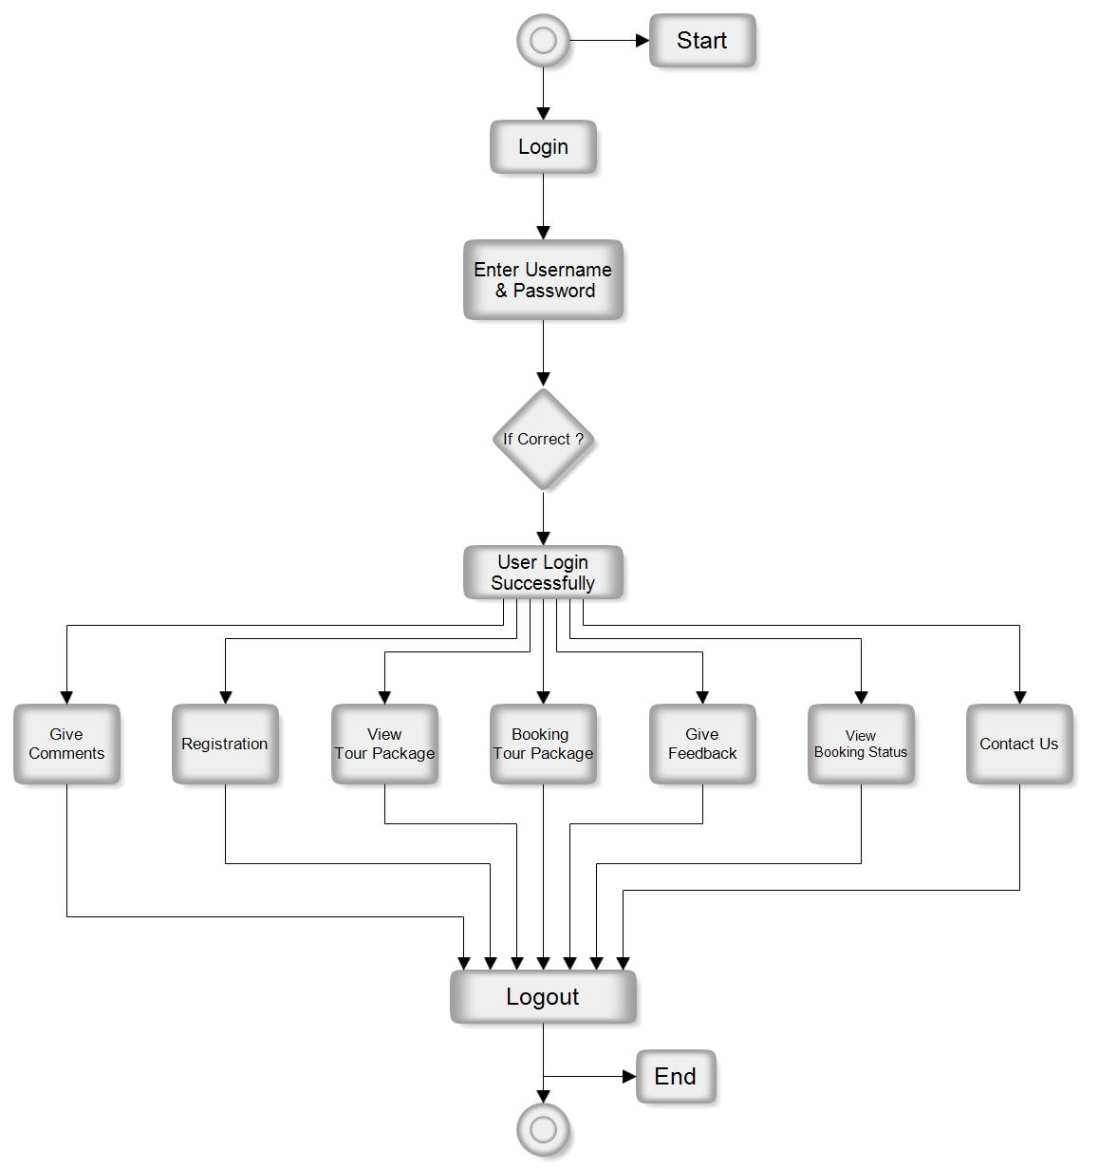

**4.7 Data Dictionary**

## Data Base Name: Tourism

 **List of Tables:**

1. **admin**
2. **user**
3. **feedback**
4. **contact**
5. **booking**
6. **package**
7. **comment**

* A data dictionary is a file or a set of files that contains a database's metadata.
* The data dictionary contains records about other objects in the database, such as data ownership, data relationships to other objects, and other data.
* The data dictionary is a crucial component of any relational database.
* Ironically, because of its importance, it is invisible to most database users. Typically, only database administrators interact with the data dictionary.
* In a relational database, the metadata in the data dictionary includes the following**:**
* Names of all tables in the database and their owners
* Names of all indexes and the columns to which the tables in those indexes relate
* Constraints defined on tables, including primary keys, foreign- key relationships to other tables, and not-null constraints

**1.Admin Table**

**Table Name**: admin

**Description:** This table is used to store Admin Login Information

.

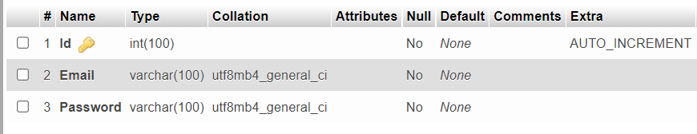

**2.User Table**

**Table Name**: user

**Description:** This table is used to store User Information

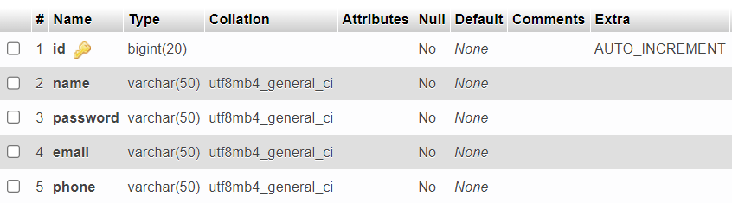

**3.Feedback Table**

**Table Name**: feedback

**Description:** This table is used to store Feedback Information

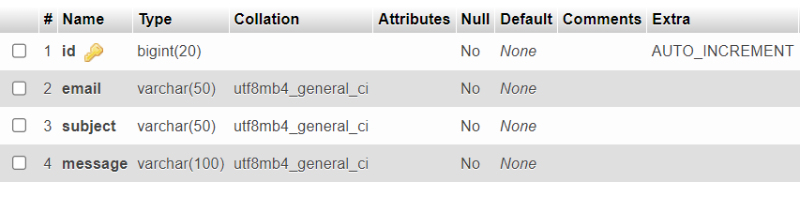

**4.Contact Table**

**Table Name**: contact

**Description:** This table is used to store Contact Information

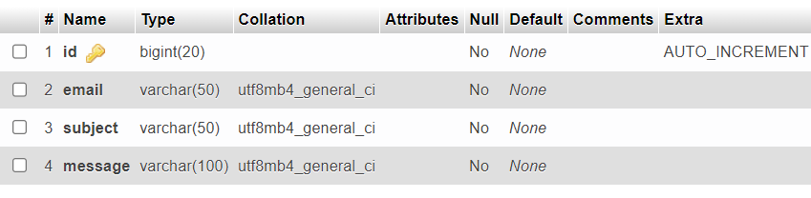

**5.Booking Table**

**Table Name**: booking

**Description:** This table is used to store Booking records

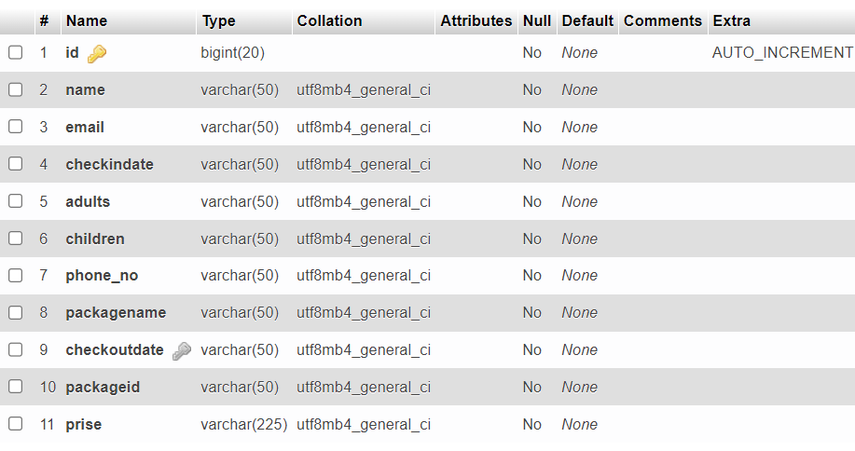

**6.Package Table**

**Table Name**: package

**Description:** This table is used to store package Information

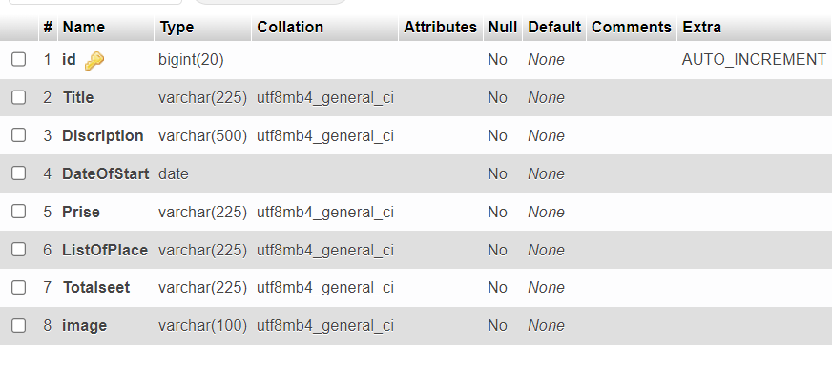

**7.Comment Table**

**Table Name**: comment

**Description:** This table is used to store comment Information

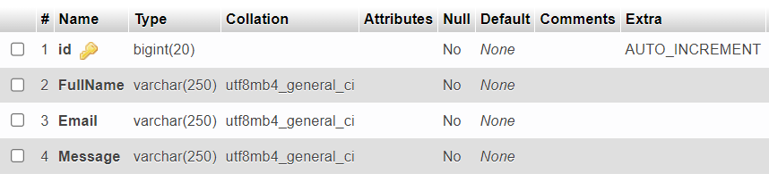

5.Screen Design

|  |  |
| --- | --- |
| 5.1 | Input Design |
| 5.2 | Output Design |
| 5.3 | Report Design |

**5.1 Input Design**

**Home Page**

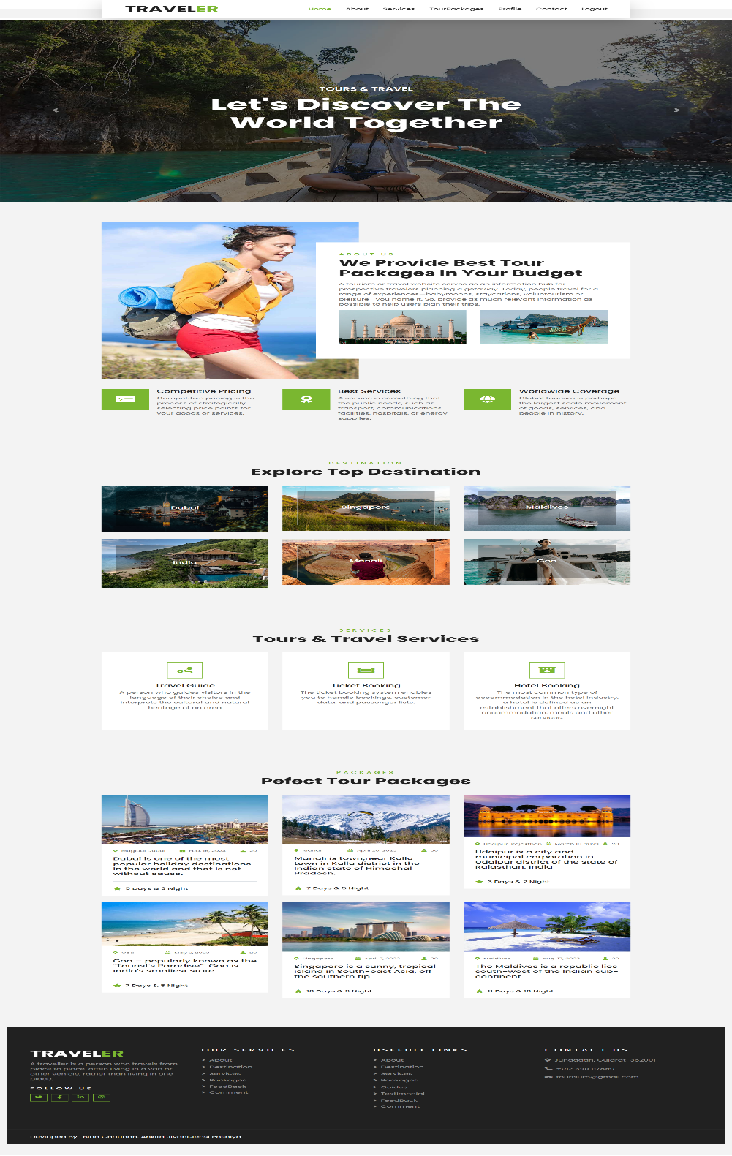

**Register Page**

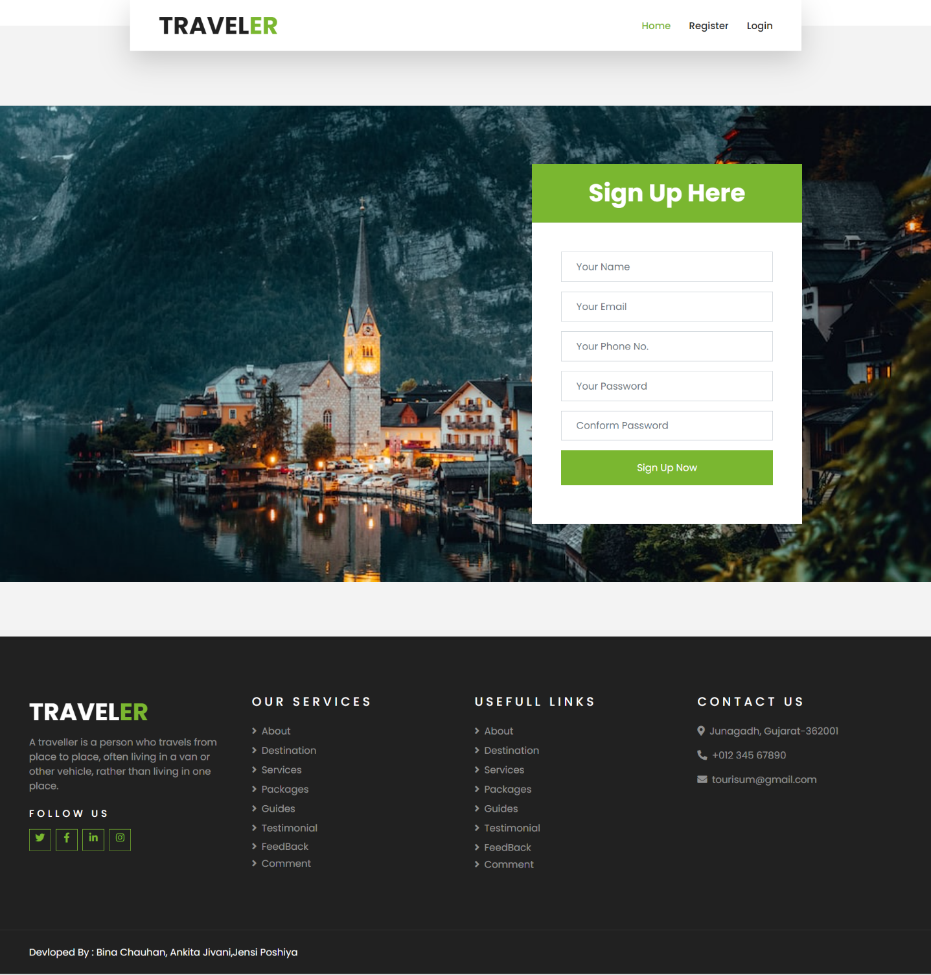

**Login Page**

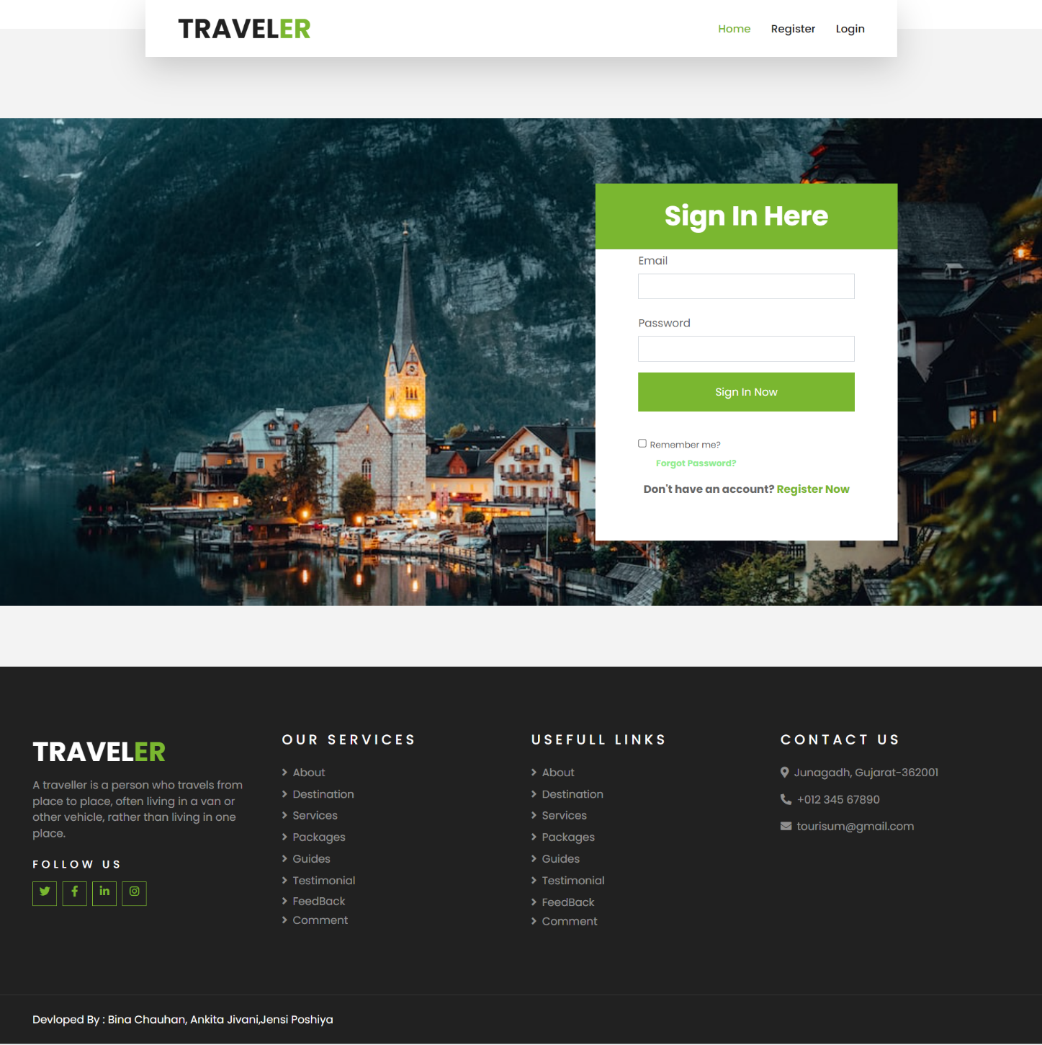

**Forget Password Page**

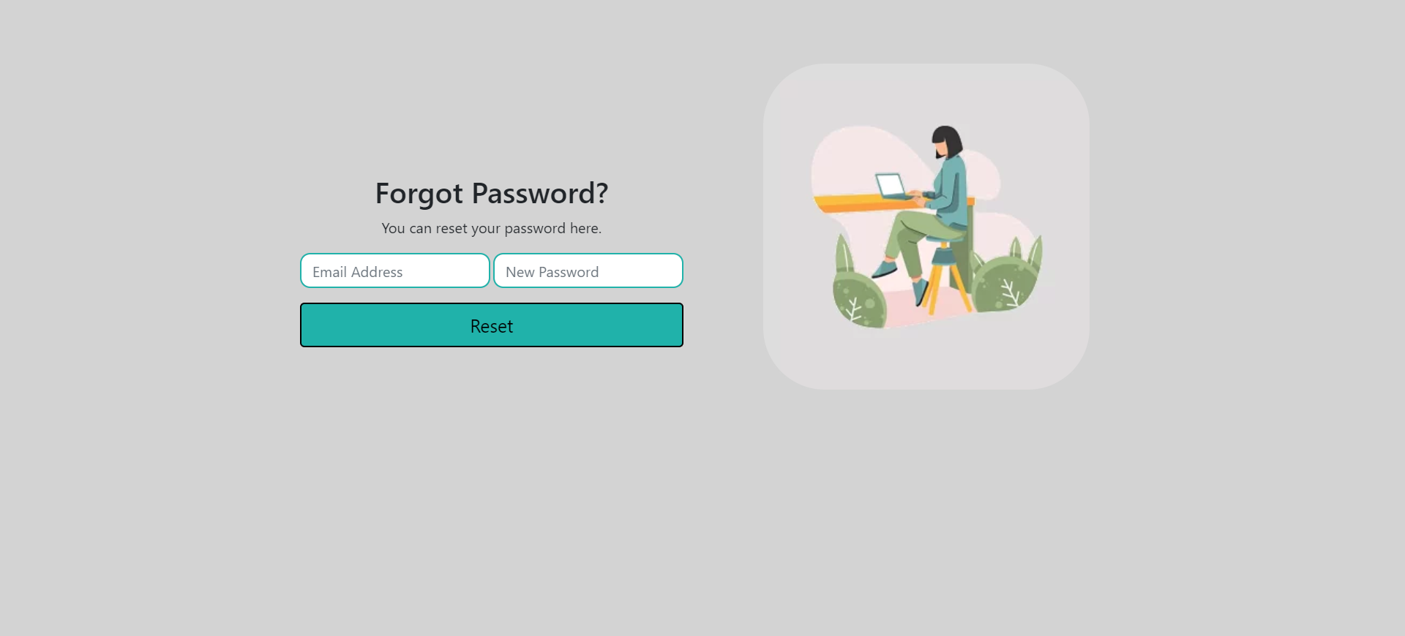

**Profile Page**

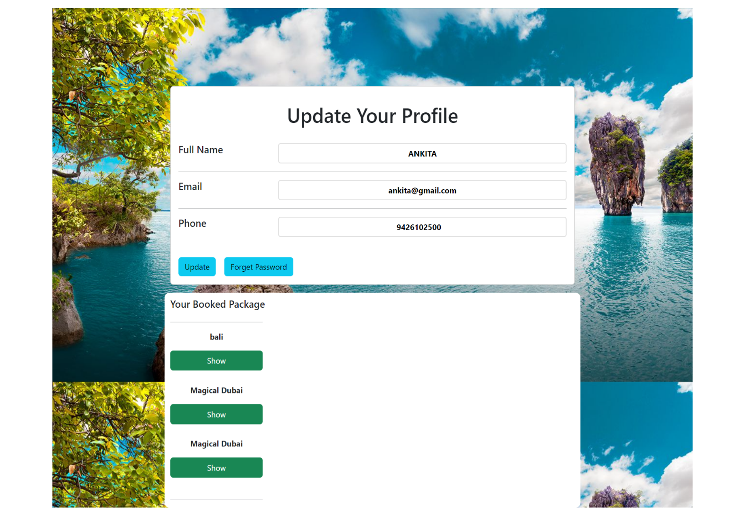

**About Page**

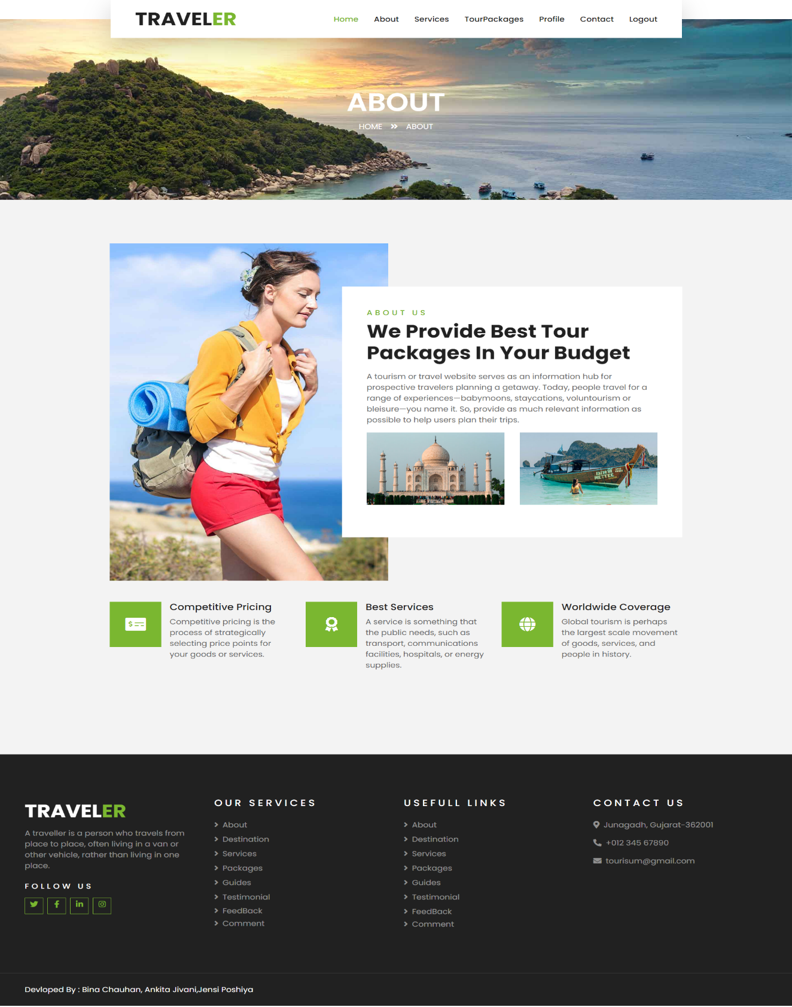

**Service Page**

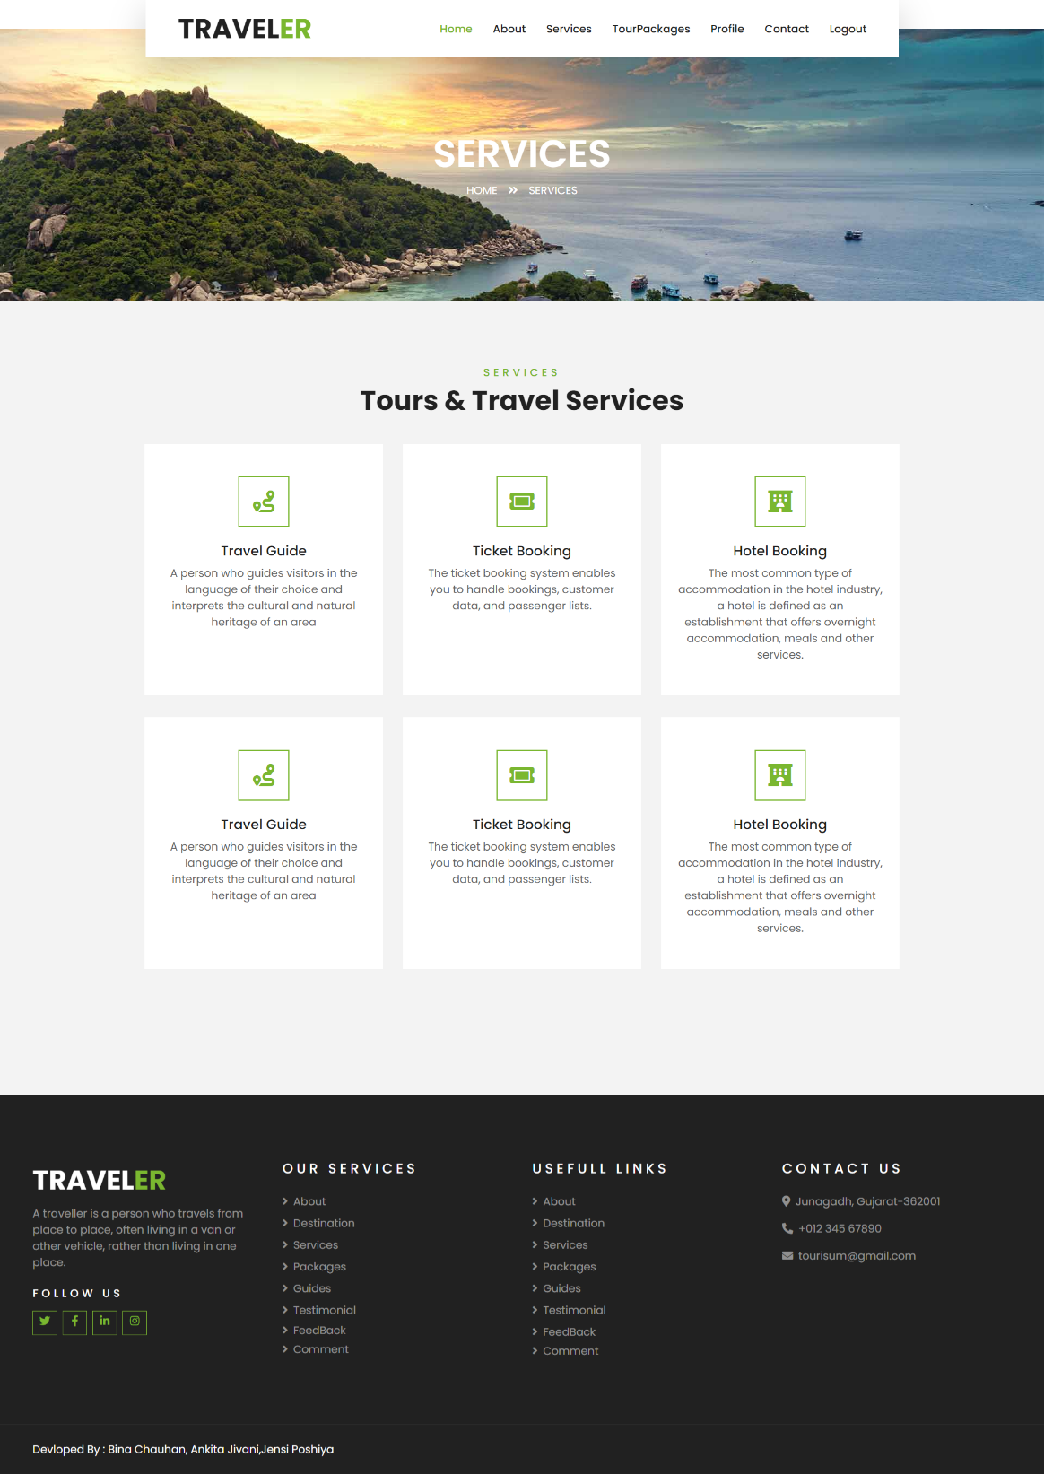

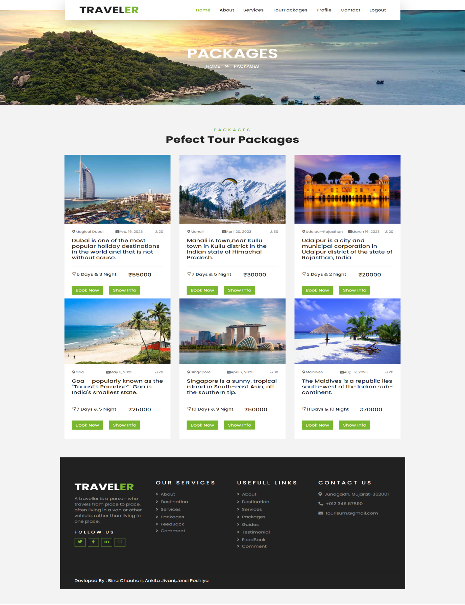**TourPackage Page**

**Booking Page**

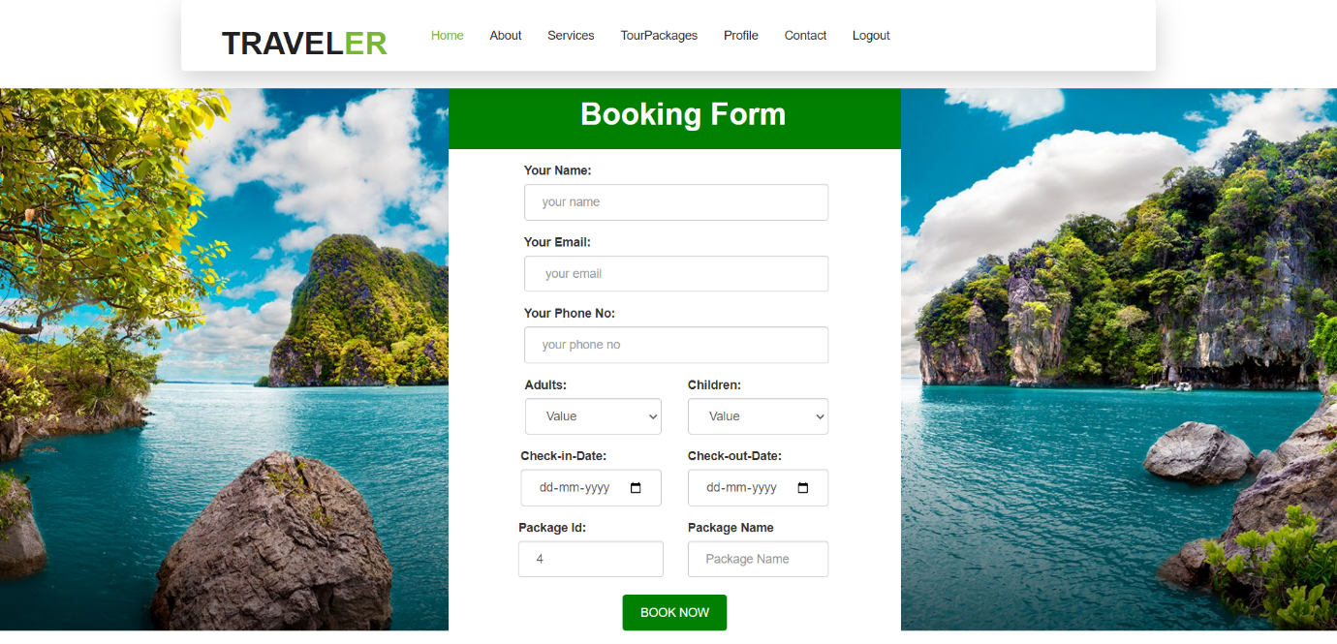

**Comment Page**

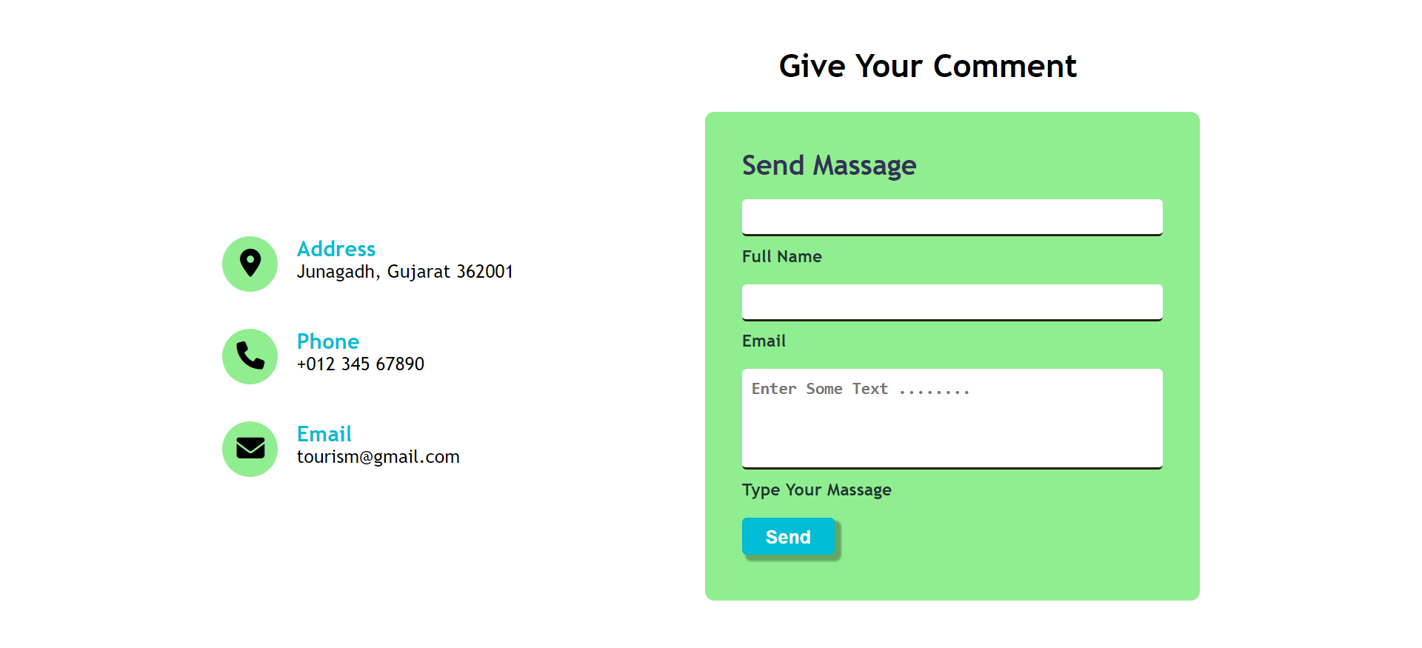

**Feedback Page**

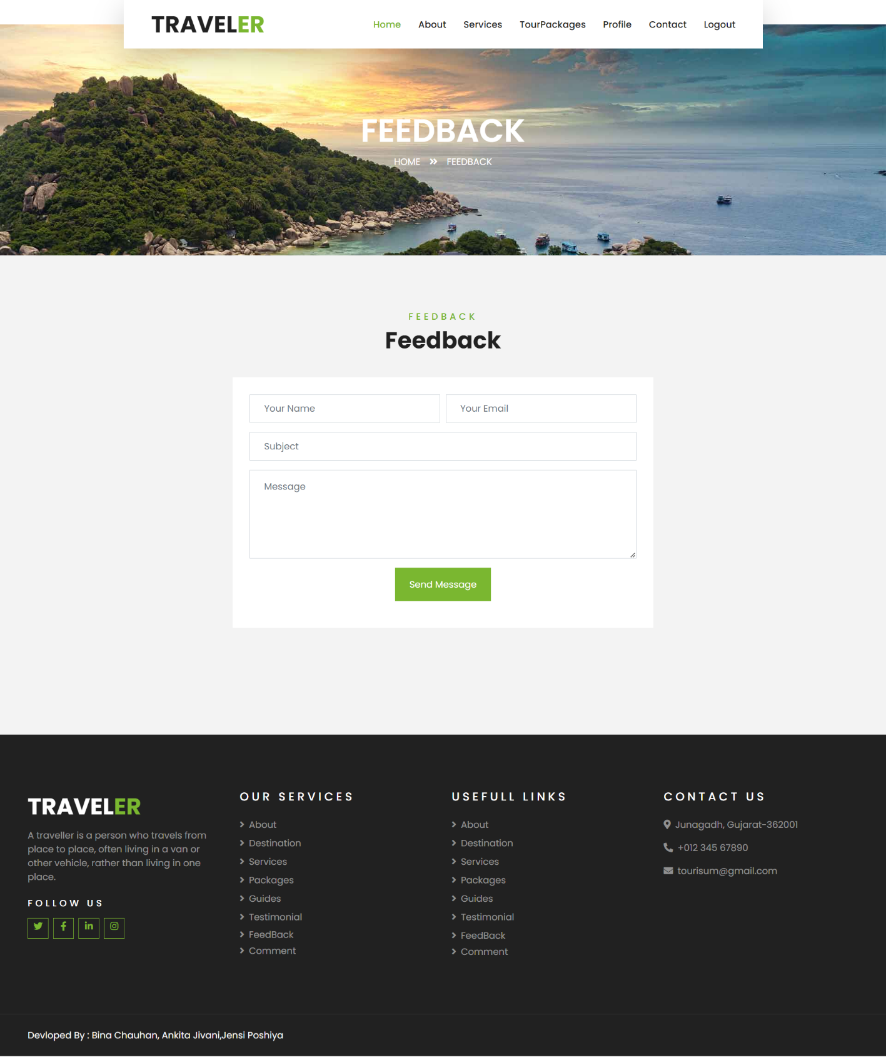

**Contact Page**

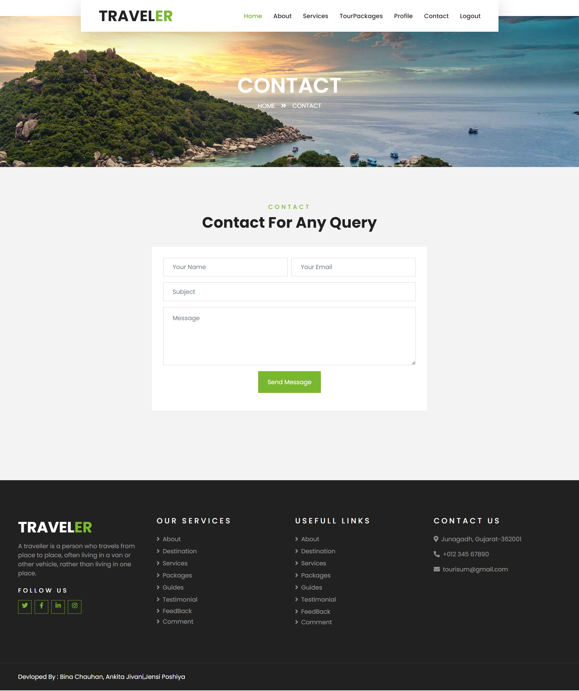

**5.1 Output Design**

**Admin Login Page**

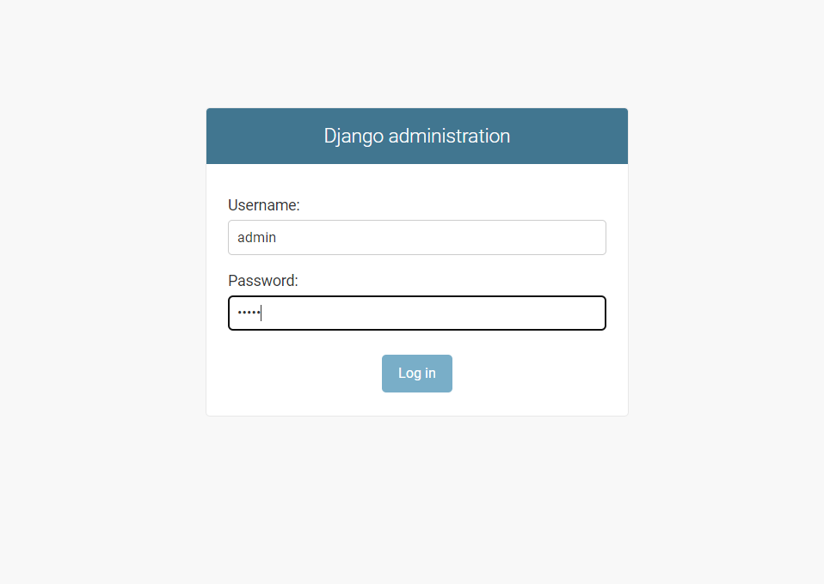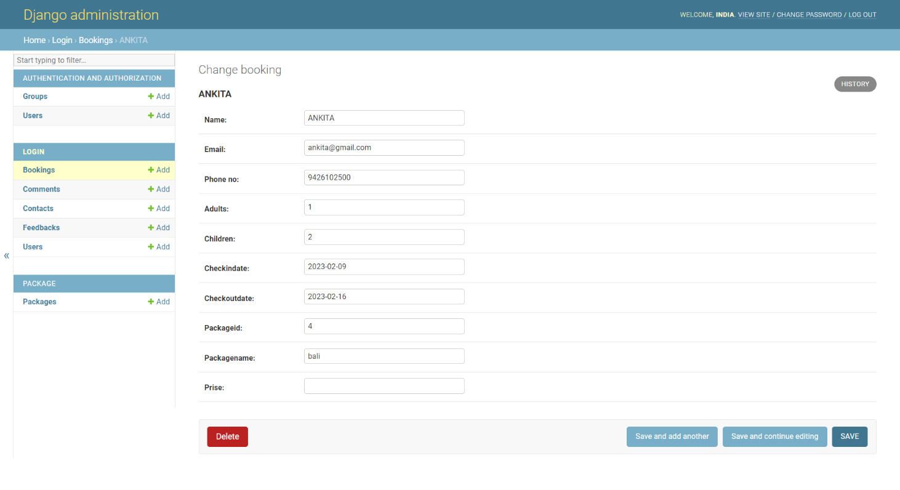 **Manage Booking Page**

**View Register User Page**

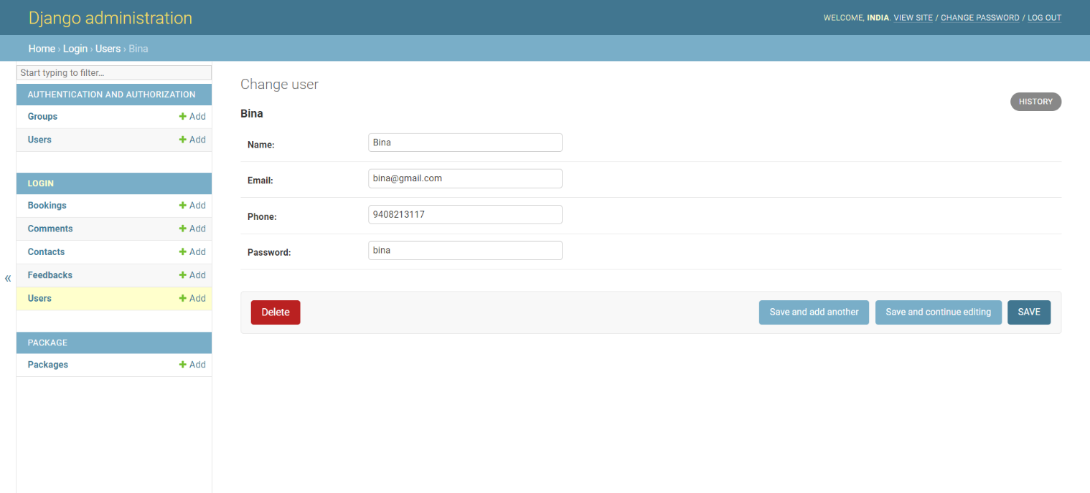**Add Package Page**

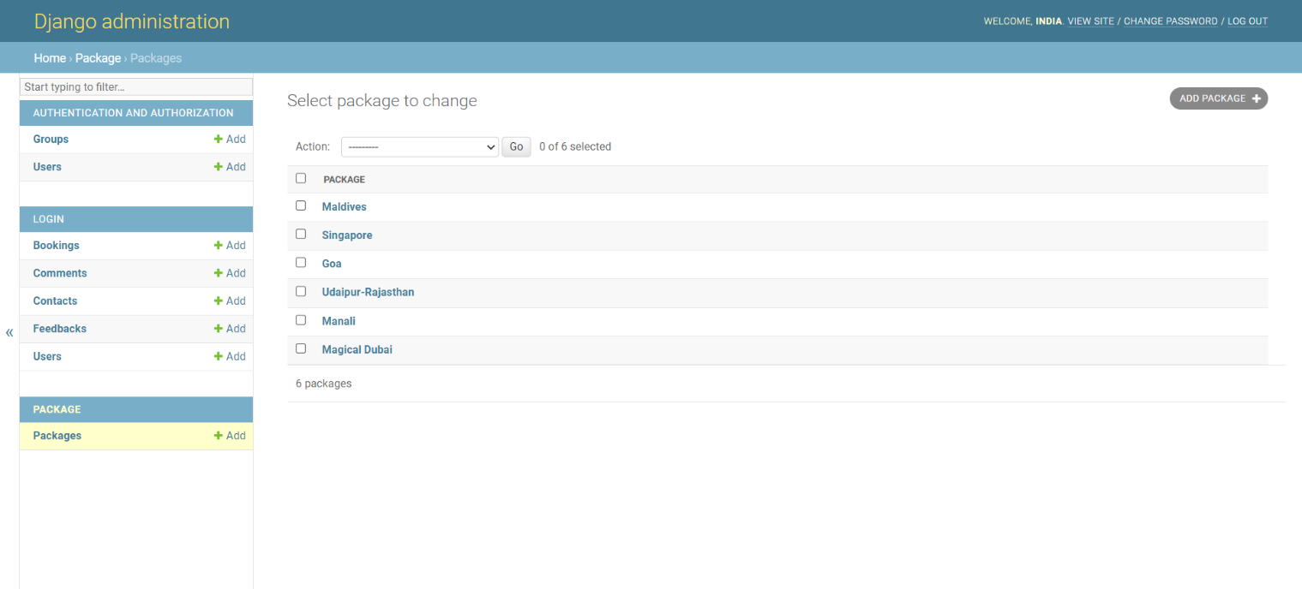

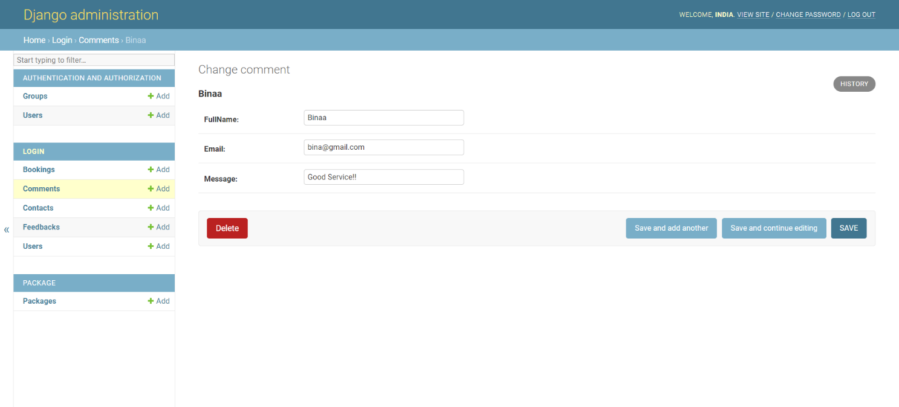**Manage Comment Page**

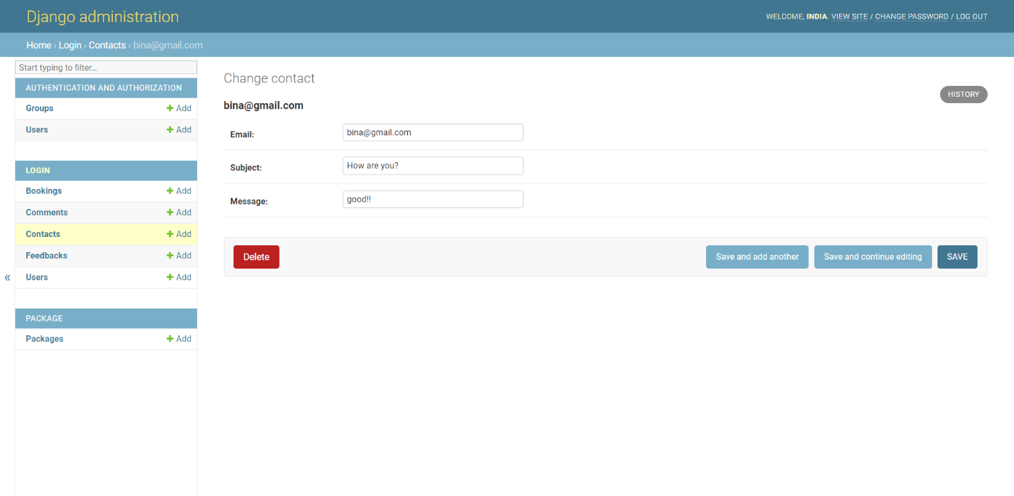**View Contact Page**

**View Feedback Page**

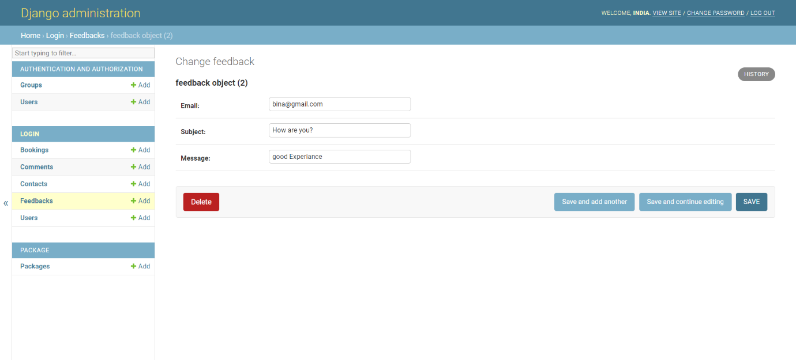

6.Coding

* **register.html**

{%load static%}

{% include 'header.html' %}

<!DOCTYPE html>

<html lang="en">

<head>

    <meta charset="UTF-8">

    <meta http-equiv="X-UA-Compatible" content="IE=edge">

    <meta name="viewport" content="width=device-width, initial-scale=1.0">

    <link rel="stylesheet" href="{% static 'css/style.css'%}">

    <title>Sinp Up Here</title>

</head>

{% if messages  %}

{% for message in messages %}

   <script>

    alert("{{message}}")

   </script>

{% endfor %}

{% endif %}

<body>

    <center>

    <div class="container-fluid bg-registration py-5" style="margin: 90px 0;" style="background-image: url('http://127.0.0.1:8000/static/image/carousel-1.jpg') !important;">

        <div class="container py-5">

            <div class="row align-items-center">

                <div class="col-lg-7 mb-5 mb-lg-0">

                    <div class="mb-4">

                    </div>

                </div>

                <div class="col-lg-5">

                    <div class="card border-0">

                        <div class="card-header bg-primary text-center p-4">

                            <h1 class="text-white m-0">Sign Up Here</h1>

                        </div>

                        <div class="card-body rounded-bottom bg-white p-5">

                            <form action="" method="post">

                                {% csrf_token %}

                                <div class="form-group">

                                    <input type="text" class="form-control p-4" placeholder="Your Name" name="name" required="required" />

                                </div>

                                <div class="form-group">

                                    <input type="email" class="form-control p-4" placeholder="Your Email" name="email" required="required" />

                                </div>

                                <div class="form-group">

                                    <input type="number" class="form-control p-4" placeholder="Your Phone No." name="phone" required="required" />

                                </div>

                                 <div class="form-group">

                                    <input type="password" class="form-control p-4" placeholder="Your Password" name="paasword" required="required" />

                                </div>

                                <div class="form-group">

                                    <input type="password" class="form-control p-4" placeholder="Conform Password" name="conformpaasword" required="required" />

                                </div>

                                <div>

                                    <button class="btn btn-primary btn-block py-3" type="submit">Sign Up Now</button>

                                </div>

                            </form>

                        </div>

                    </div>

                </div>

            </div>

        </div>

    </div>

    </center>

    {% include 'footer.html' %}

</body>

</html>

* **login.html**

{%load static%}

{% include 'header.html' %}

<!DOCTYPE html>

<html lang="en">

<head>

    <meta charset="UTF-8">

    <meta http-equiv="X-UA-Compatible" content="IE=edge">

    <meta name="viewport" content="width=device-width, initial-scale=1.0">

    <link rel="stylesheet" href="{% static 'css/style.css'%}">

    <title>Sign In Here</title>

</head>

<body>

    {% if messages  %}

    {% for message in messages %}

       <script>

        alert("{{message}}")

       </script>

    {% endfor %}

{% endif %}

<div class="main" >

    <div class="container-fluid bg-registration py-5" style="margin: 90px 0;" style="background-image: url('https://th.bing.com/th/id/OIP.iSu2RcCcdm78xbxNDJMJSgHaEo?w=295&h=184&c=7&r=0&o=5&dpr=1.3&pid=1.7') !important;">

        <div class="container py-5">

            <div class="row align-items-center">

                <div class="col-lg-7 mb-5 mb-lg-0">

                    <div class="mb-4">

                    </div>

                </div>

                <div class="col-lg-5">

                    <div class="card border-0">

                        <div class="card-header bg-primary text-center p-4">

                            <h1 class="text-white m-0">Sign In Here</h1>

                        </div>

                        <div class="card-body rounded-bottom bg-white p-5">

                            <form action="" method="post">

                                {% csrf_token %}

        <div class="login" style="width: 100%; margin-top: -50px;">

            <div class="container">

                <div class="login-form-grids animated wow slideInUp" data-wow-delay=".5s">

                <form method="POST" name="register" onsubmit="return reqvalidateForm(this)" style="width:450px;">

                    <div class="form-group">

                            <label for="recipient-email" class="col-form-label">Email</label>

                            <input type="email" class="form-control" placeholder="" name="Email" id="email"

                                required="">

                    </div>

                    <div class="form-group">

                            <label for="password1" class="col-form-label">Password</label>

                            <input type="password" class="form-control" placeholder="" name="Password" maxlength="8" id="password1"

                                required="">

                    </div>

                    <div>

                        <button class="btn btn-primary btn-block py-3" type="submit">Sign In Now</button>

                    </div>

                    <div class="row sub-w3l my-3">

                        <div class="col-sm-6 sub-w3_pvt" style="margin-top: 20px;">

                            <input type="checkbox" id="brand1"  value="">

                            <label for="brand1" style="display: inline-block; font-size: 13px; float: center;">

                                <span></span>Remember me?</label>

                                <a href="/forget" class="text-secondary" style=" float: right;  color:lightGreen !important; font-size:13px;  font-weight: bold;">Forgot Password?</a>

                        </div>

                    </div>

                    <p class="text-center dont-do modal-footer1" style="text-align: center; color: #666666; font-weight: bold;">Don't have an account?

                            <b><a href="register" class="font-weight-bold"

                                data-blast="color">Register Now</a></b>

                    </p>

                </form>

            </div>

        </div>

    </div>

</div>

    {% include 'footer.html' %}

</body>

</html>

* **views.py**

from django.shortcuts import render,HttpResponse,redirect

from django.contrib.auth.models import User

from django.contrib import messages

from .models import *

# Create your views here.

def register(request):

    if request.method=='POST':

        name=request.POST.get('name')

        email=request.POST.get('email')

        mn=request.POST.get('phone')

        destination=request.POST.get('destination')

        pwd=request.POST.get('paasword')

        cpwd=request.POST.get('conformpaasword')

        print(name)

        print(email)

        print(mn)

        print(destination)

        print(pwd)

        fatch=user.objects.filter(email=email)

        print(fatch)

        if not fatch:

            if not pwd==cpwd:

                messages.error(request,"Password and Conform password is not correct!")

            else:

                new=user()

                new.name=name

                new.phone=mn

                new.destination=destination

                new.password=pwd

                new.email=email

                new.save()

                messages.error(request,"Register Successfully!!")

                return redirect('login')

        else:

            messages.error(request,"User Already Exist !!")

    return render(request,"register.html")

def login(request):

    if request.method=='POST':

       emai=request.POST.get('Email')

       pwd=request.POST.get('Password')

       if user.objects.filter(email=emai).values():

          fatch=user.objects.filter(email=emai)

          passw=fatch[0].password

          if pwd==passw:

           print(fatch[0].id)

           request.session['id']=fatch[0].id

           print(request.session['id'])

           messages.error(request,"Login Successfully!!")

           return redirect('/')

          else:

           messages.error(request,"Password is Incorrect")

       else:

            messages.error(request,"User Does Not Exist")

    return render(request,'login.html')

def logout(request):

    request.session['id']=""

    messages.error(request,"Logout Successfull")

    return redirect('/')

* **tourpackage.html**

{%load static%}

{% include 'header.html' %}

<!DOCTYPE html>

<html lang="en">

<head>

    <meta charset="UTF-8">

    <meta http-equiv="X-UA-Compatible" content="IE=edge">

    <meta name="viewport" content="width=device-width, initial-scale=1.0">

    <link rel="stylesheet" href="{% static 'css/style.css'%}">

    <title>Tour Package page</title>

</head>

<body>

        <!-- Header Start -->

        <div class="container-fluid page-header" style="background-image: url('http://127.0.0.1:8000/static/image/carousel-2.jpg'); ">

            <div class="container">

                <div class="d-flex flex-column align-items-center justify-content-center" style="min-height: 400px">

                    <h3 class="display-4 text-white text-uppercase">Packages</h3>

                    <div class="d-inline-flex text-white">

                        <p class="m-0 text-uppercase"><a class="text-white" href="">Home</a></p>

                        <i class="fa fa-angle-double-right pt-1 px-3"></i>

                        <p class="m-0 text-uppercase">Packages</p>

                    </div>

                </div>

            </div>

        </div>

        <!-- Header End -->

    <!-- Packages Start -->

    <link rel="stylesheet" href="https://cdn.jsdelivr.net/npm/bootstrap-icons@1.10.3/font/bootstrap-icons.css">

    <div class="container-fluid py-5">

        <div class="container pt-5 pb-3">

            <div class="text-center mb-3 pb-3">

                <h6 class="text-primary text-uppercase" style="letter-spacing: 5px;">Packages</h6>

                <h1>Pefect Tour Packages</h1>

            </div>

            <div class="row">

            {% for item1 in item %}

                <div class="col-lg-4 col-md-6 mb-4">

                    <div class="package-item bg-white mb-2">

                        <img class="img-fluid" src="http://127.0.0.1:8000/media/{{item1.image}}" alt="" style="height: 50%; width: 100%; " >

                        <div class="p-4">

                            <div class="d-flex justify-content-between mb-3">

                                <small class="m-0"><i class="fa fa-map-marker-alt text-primary mr-2"><i class="bi bi-geo-alt-fill"></i></i></i>{{item1.Title}}</small>

                                <small class="m-0"><i class="fa fa-calendar-alt text-primary mr-2"><i class="bi bi-calendar-date-fill"></i></i>{{item1.DateOfStart}}</small>

                                <small class="m-0"><i class="fa fa-user text-primary mr-2"><i class="bi bi-person"></i></i>{{item1.Totalseet}}</small>

                            </div>

                            <a class="h5 text-decoration-none" href="">{{item1.Discription}}</a>

                            <div class="border-top mt-4 pt-4">

                                <div class="d-flex justify-content-between">

                                    <h6 class="m-0"><i class="fa fa-star text-primary mr-2"><i class="bi bi-shop"></i></i>{{item1.ListOfPlace}}<small></small></h6>

                                    <h5 class="m-0">&#8377;{{item1.Prise}}</h5>

                                    <br>

                                </div>

                            </div>

                            <div class="ce" style="display: flex; padding-top:30px;" >

                            <form action="/booking" method="get ">

                            <input type="submit" class="btn btn-primary mt-1" value="Book Now" style="height: 38px; margin-right: 20px;">

                        </form>

                            <form action="/packagedetails/" method="post">

                                {% csrf_token %}

                            <input type="hidden" name="id" value="{{item1.id}}">

                            <input type="submit"class="btn btn-primary mt-1" value="Show Info">

                            </form>

                        </div>

                        </div>

                    </div>

                </div>

                {% endfor %}

{% include 'footer.html' %}

</body>

</html>

* **views.py**

from django.shortcuts import HttpResponse,render,redirect

from login.models import contact,booking,user

from login.models import feedback,comment

from package.models import package

from django.contrib import messages

def booking1(request):

    if request.method=="POST":

        name=request.POST.get('name')

        email=request.POST.get('email')

        phonenumber=request.POST.get('phone_no')

        adult=request.POST.get('adults')

        children=request.POST.get('children')

        checkindate=request.POST.get('checkindate')

        checkoutdate=request.POST.get('checkoutdate')

        packageid=request.POST.get('packageid')

        packagename=request.POST.get('packagename')

        print(name,email,phonenumber,adult,children,checkindate,checkoutdate,packageid,packagename)

        save=booking()

        save.name=name

        save.email=email

        save.phone_no=phonenumber

        save.adults=adult

        save.children=children

        save.checkindate=checkindate

        save.checkoutdate=checkoutdate

        save.packageid=packageid

        save.packagename=packagename

        save.save()

        messages.error(request,"Booking Successfully...!")

    data=user.objects.get(id=request.session['id'])

    context={

        'item':data

    }

    return render (request,'booking.html',context)

* **models.py**

from django.db import models

class user(models.Model):

    name=models.CharField(max_length=50)

    email=models.EmailField(max_length=50)

    phone=models.CharField(max_length=50)

    password=models.CharField(max_length=50)

    def __str__(self):

         return self.name

class contact(models.Model):

    name=models.CharField(max_length=50),

    email=models.EmailField(max_length=50)

    subject=models.CharField(max_length=50)

    message=models.CharField(max_length=100)

    def __str__(self):

        return self.email

class feedback(models.Model):

    name=models.CharField(max_length=50),

    email=models.EmailField(max_length=50)

    subject=models.CharField(max_length=50)

    message=models.CharField(max_length=100)

class booking(models.Model):

    name=models.CharField(max_length=50)

    email=models.EmailField(max_length=50)

    phone_no=models.CharField(max_length=50)

    adults=models.CharField(max_length=50)

    children=models.CharField(max_length=50)

    checkindate=models.CharField(max_length=50)

    checkoutdate=models.CharField(max_length=50)

    packageid=models.CharField(max_length=50)

    packagename=models.CharField(max_length=50)

    prise=models.CharField(max_length=225)

    def __str__(self):

        return self.name

7.Testing (Manual ,Test Cases ,Test Data)

|  |  |
| --- | --- |
| 7.1 | Manual Testing |
| 7.2 | Test Case |

## Testing Mechanism

* Testing is process to finding the errors in the program.
* Testing is a process to show the corrections of the program.
* Testing is needed to show completeness, to improve the quality of the software and to provide the maintenance aid.
* Some testing standards are therefore necessary reduce the testing costs and operation time.
* Testing software extends throughout the coding phase and it represents the ultimate review of configurations, design and coding. Based on the way the software reacts to these testing.
* We can decide whether the configuration that has been built is study or not.
* All components of an application are tested, as the failure to do so many results in a series of bugs after the software is put to use.

**1.Unit Testing :**

* This site is designed for Information Technology Professionals who need to improve quality and require guidance and direction to help teams consistently produce error free results.
* It provides information management guidelines for software unit testing.

**2.Black-box Testing :**

* This testing methodology looks at what are the available inputs for an application and what the expected outputs are that should result from each input.
* Black box testing also called behavioural testing, focuses on the functional requirement of software.
* This testing approach enables the software engineer to drive the input conditions that will fully exercise all requirements for a program.

**3.White-box Testing :**

* White box testing is also called Glass box testing is a test case design control structure of the procedural design to derive test cases using white box testing method.
* This testing methodology looks under the covers and into the subsystem of an application. White-box testing enables you to see what is happening inside the application.
* The software engineer can drive the test cases that guarantee that all independent paths within the module have been exercised at least once.

**4.Grey-box** **Testing :**

* Grey-box testing is a technique to test the application with having a limited knowledge of the internal workings of an application.
* In software testing, the phrase *the more you know, the better* carries a lot of weight while testing an application.
* Mastering the domain of a system always gives the tester an edge over someone with limited domain knowledge.
* Having this knowledge, a tester can prepare better test data and test scenarios while making a test plan.

8.Enhancement

|  |  |
| --- | --- |
| 8.1 | Advantages of Your Project |
| 8.2 | Limitation of Your Project |
| 8.3 | Future Scope |

**8.1 Advantages of Your Project**

* Makes life easier for travel managers.
* Improves operations management.
* Automation saves time which can be used in better ways.
* Improves business reporting.
* Simplifies expense report management.
* **Tourism  promotes international connections**
* Tourism can provide a significant source of income for local communities
* Tourism gives the locality a chance to show itself off and raise its profile in the world.
* Tourism can provide much-needed employment for people.

**8.2 Limitation of Your Project**

* Online payment is not available.
* Mandatory sign-up needed for the Ticket Book. But user can visit the site with out sign-in or sign-up.
* Only read module for viewer.
* Different rights for actors.

**8.3 Future Scope**

* Payment method will be available.
* New customization in website.
* Add New Services
* Some UI Changes
* More modules will be updated.
* Bug fixes and performance.
* More attractive

9.References

* For the successful working of our project we are referred many sources for the code snippets, logic and tips and tricks from the various web sites. Most I searched for the required possessions on the google.com search engine.
* **Sites: -**
* https://www.allindiapackages.com/
* <https://www.tourism-of-india.com/>
* <https://www.shreembrzeetravels.com/>
* <https://www.holidify.com/>
* https://www.tourmyindia.com/

